

**EKITI STATE GOVERNMENT**

SEPTEMBER, 2023

EKITI STATE GOVERNMENT

Budget Performance Report FOR 2023 QUARTER 3

Contents

1 Summary of Performance 2

1.A Introduction 2

1.B Revenue Performance 2

1.C Recurrent Expenditure Performance 3

1.D Capital Expenditure Performance 3

1.E Conclusions 4

2 Budget Reports 5

2.A Summary 5

2.B Revenue by Administrative Classification 6

2.C Revenue by Economic Classification 9

2.D Expenditure by Administrative Classification 14

2.E Expenditure by Economic Classification 36

2.F Expenditure by Function 42

**List of Reports**

Table 1: Budget Summary 5

Table 2: Total Revenue by Administrative Classification 6

Table 3: Total Revenue by Economic Classification 9

Table 4: Total Expenditure by Administrative Classification 14

Table 5: Personnel Expenditure by Administrative Classification 21

Table 6: Overhead Expenditure by Administrative Classification 24

Table 7: Capital Expenditure by Administrative Classification 31

Table 8: Other Expenditure by Administrative Classification 35

Table 9: Total Expenditure by Economic Classification 36

Table 10: Total Expenditure by Function 42

Table 11: Personnel Expenditure by Function 45

Table 12: Overhead Expenditure by Function 47

Table 13: Capital Expenditure by Function 49

Table 14: Other Expenditure by Function 51

# Summary of Performance

## Introduction

This Budget Performance Report for Ekiti State is prepared quarterly and issued within four (4) weeks from the end of each quarter.

This Report includes the original approved Budget appropriation for the year 2023 against each organizational unit for each of the core economic classification of expenditure (Personnel, Overheads, Capital and Others), the actual expenditure for the Quarter (Q3) attributed to each organizational unit, as well as the cumulative expenditure for year to date and balances against each of the revenue and expenditure Appropriations.

The core economic classifications are:

* Personnel – Economic Sub-Account Type 21
* Overheads – Economic Account Class 2202
* Capital - Economic Sub-Account Type 23
* Others - Economic Account Classes 2203-2209 as applicable

This Budget Performance Report is produced by the Ministry of Budget, Economic Planning and Performance Management in conjunction with the Ministry of Finance and Economic Development, Office of the State Accountant-General, Office of the State Auditor-General and Internal Revenue Service which constitute Fiscal Coordinating Agencies and published on the Ekiti State website at <http://www.ekitistate.gov.ng/>

## Revenue Performance

1. **OPENNING BALANCE:** The sum of N10,124,260,534.56 was transferred from the prior year as actual opening balance at the beginning of the 2023 fiscal year as produced by the office of the Accountant General. However, following the production of the Audited Financial Statement, the figure changed to N9,994,754,409.91 which represents the sectoral position as at 1st January, 2023.
2. **STATUTORY ALLOCATION (Federal Allocation and Value Added Tax):** The sum of N64,542,117,000.20 was projected as Government Share of Statutory Allocation (Federal Allocation and Value Added Tax) in the 2023 Budget. However, the sum of N28,882,268,487.04 was realized during the period under review, while year to date was N61,307,600,542.95 which represents 95.0**%** performance. The performance in the Statutory Allocation could be attributed to the following:
3. improvement in exchange gain and savings from subsidy removal on Premium Motor Spirit (PMS).
4. improved economic activities.

**Note**: The State received the sum of N9 billion as additional FAAC in the month of August based on the returns from the Office of the State Accountant General.

The actual Domestic Debt Service as at Q3 is N4,049,874,843.38. This has been inputed into the Excel Template.

1. **INDEPENDENT REVENUE (IGR):** The sum of N15,820,461,854.09 was approved as revenue estimates from Independent Revenue sources in the 2023 Budget. The sum of N5,836,692,087.59 was realized within Q3, while year to date stood at N16,623,735,704.31 which represents 105.1% performance. The impressive performance could be attributed to the improved means of collection.
2. **AIDS AND GRANTS:** The sum of N22,710,139,669.53 was projected as revenue from Aids and Grants in 2023 Fiscal year. However, the sum of N1,555,627,500.00 was realized in the Third Quarter (Q3) while year to date was N9,462,613,162.39 which represents 41.7% performance.
3. **CAPITAL DEVELOPMENT FUND (CDF) RECEIPTS:** Under this Revenue Head, the sum of **N**5,500,000,000.00 was projected as revenue in the 2023 Budget. However, N3,031,076,059.82 was realized at end of Third Quarterwhich translates to 55.1**%** performance.

## Recurrent Expenditure Performance

This is made up of Personnel Cost and Other Recurrent Costs.

* Personnel Cost**:** Under this Expenditure Head, the sum of N30,349,822,491.81 was earmarked for Personnel Estimate in 2023. The actual Personnel Cost stood at N9,120,672,405.09in Q3, **while** year to date wasN22,738,880,854.79, representing 74.9% performance.
* Other Recurrent Cost**:** The sum of N49,160,810,567.08 was earmarked for other Recurrent Cost in the 2023 Budget. However, the sum of N15,631,754,812.18 was spent on this Expenditure Head within the Quarter, while year to date was N42,860,520,991.42 which represents 87.2% performance.

**Note**: All overspending have been noted for consideration and upward review in the 2023 Revised/Supplementary Budget which is currently in the State House of Assembly.

## Capital Expenditure Performance

* **Capital Expe**n**diture:** The sum of **N34,062,085,464.93** was earmarked for Capital Projects in 2023 Budget. In the Third Quarter (Q3), the Actual Capital Expenditure in the Third Quarter is N8,866,494,986.82, while the actual expenditure to date was **N18,571,768,715.76** which represents 54.5% performance.

## Conclusions

The Third Quarter (Q3) Budget Performance Report (BPR) was carried out in line with the uniform Template as agreed with the Sub-nationals. It also in line with the National Chart of Accounts (NCOA) with a view to determining the actual level of performances on Revenue and Expenditure by MDAs in the Third Quarter of the year. The overall 2023 Revenue Budget Performance was **84.7%,** while the Total Expenditure performance for the period under review stood at **74.1%**.

# Budget Reports

## Summary

Table : Budget Summary

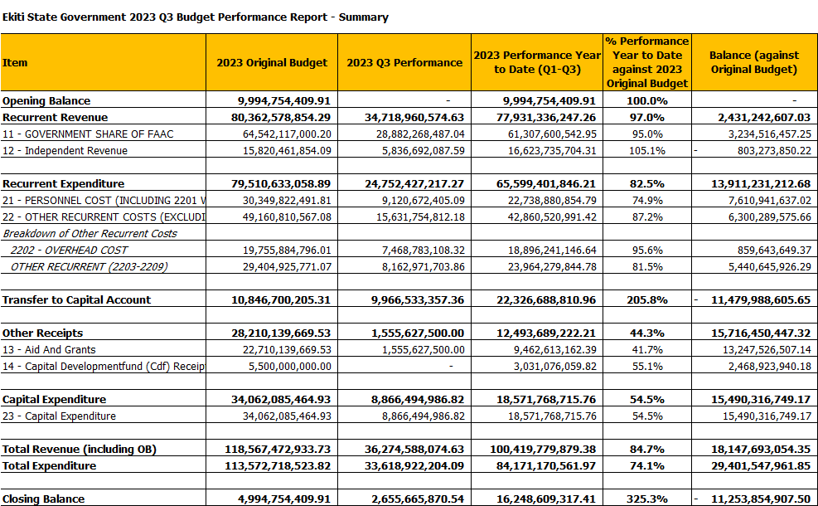

## Revenue by Administrative Classification

Table : Total Revenue by Administrative Classification

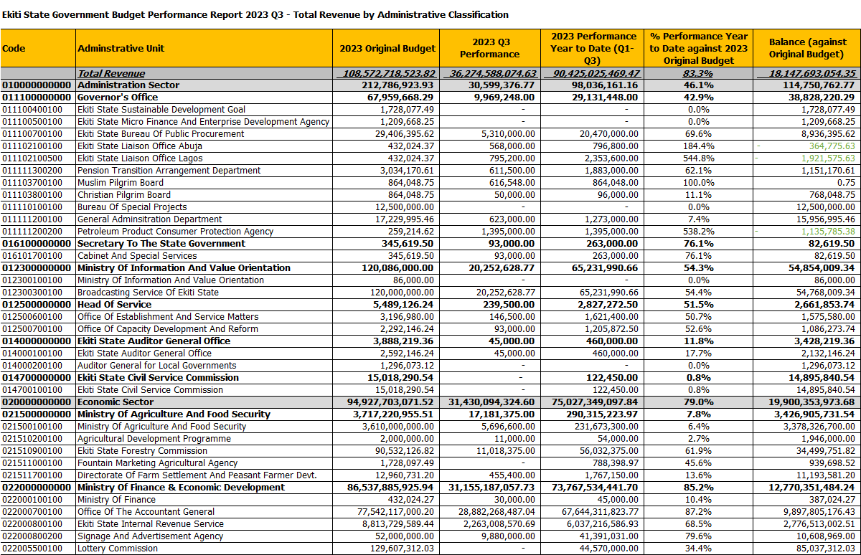



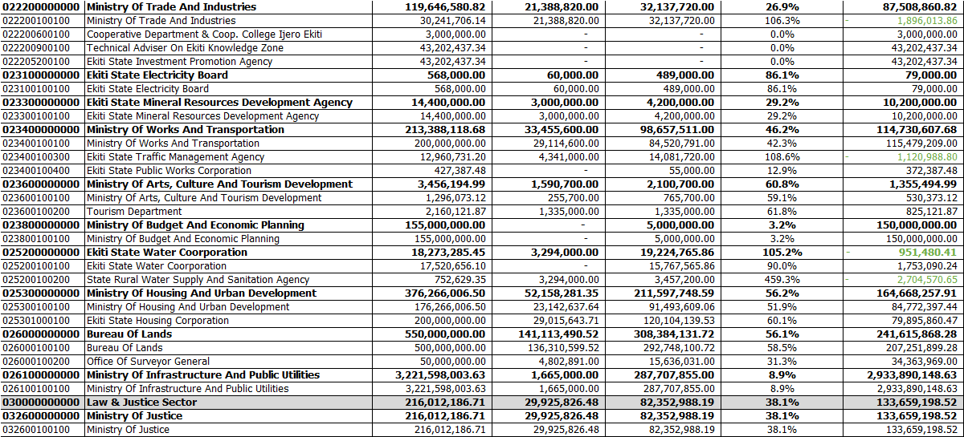



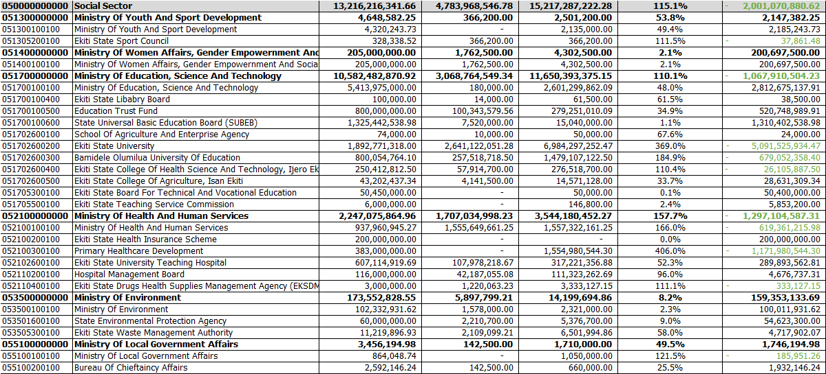

## Revenue by Economic Classification

Table : Total Revenue by Economic Classification

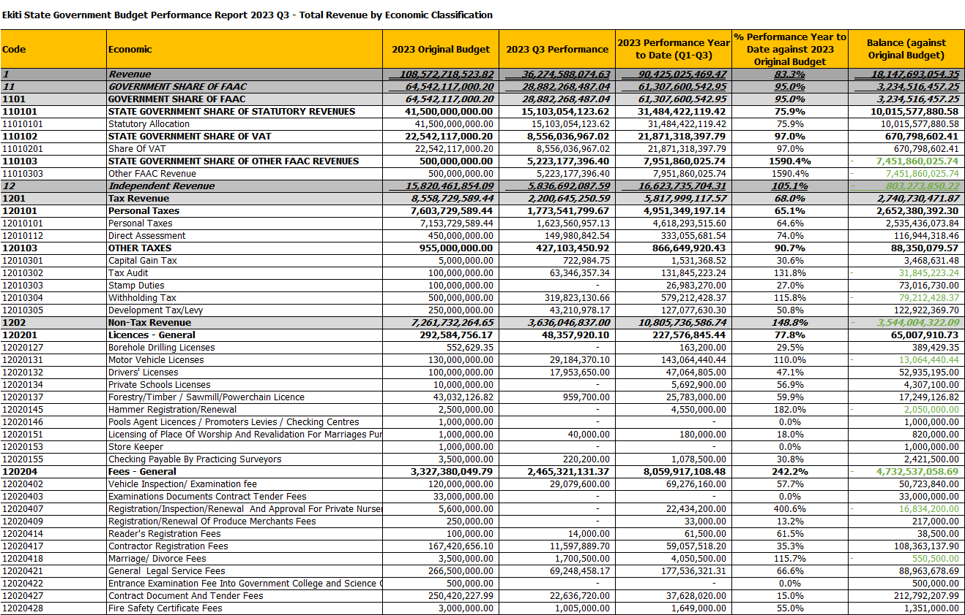



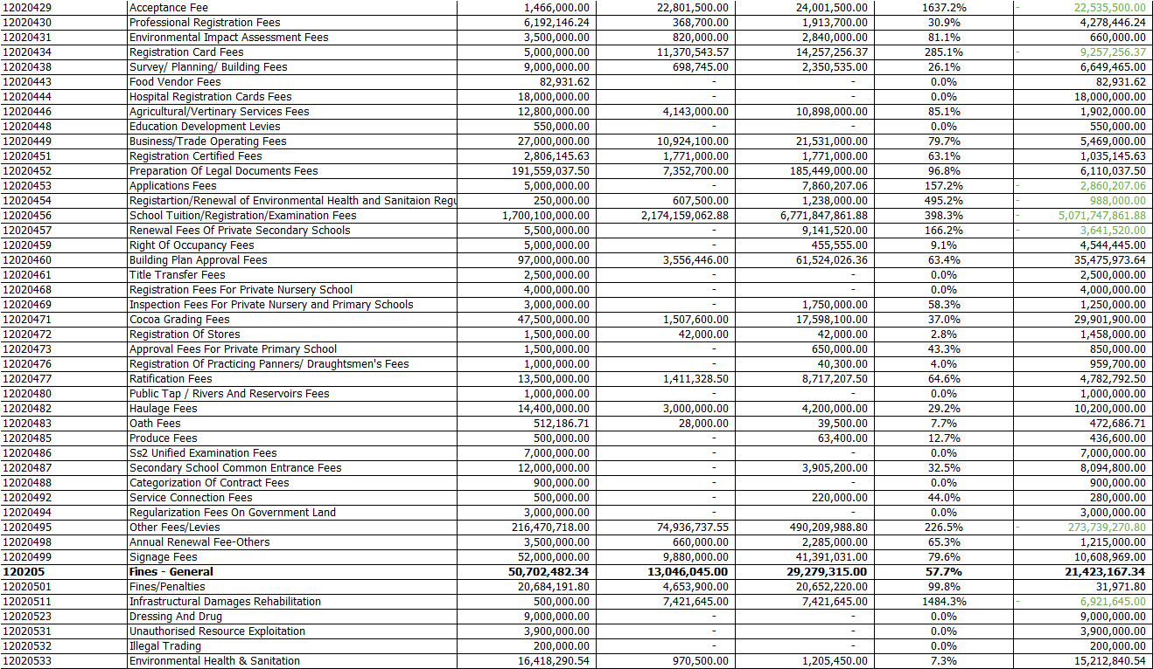



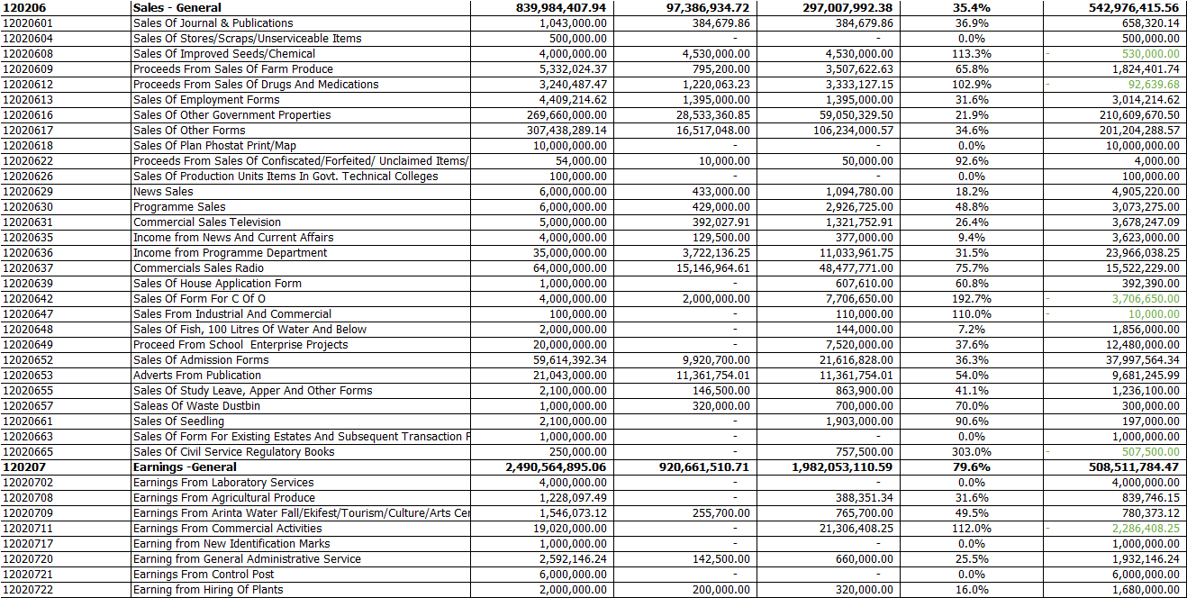



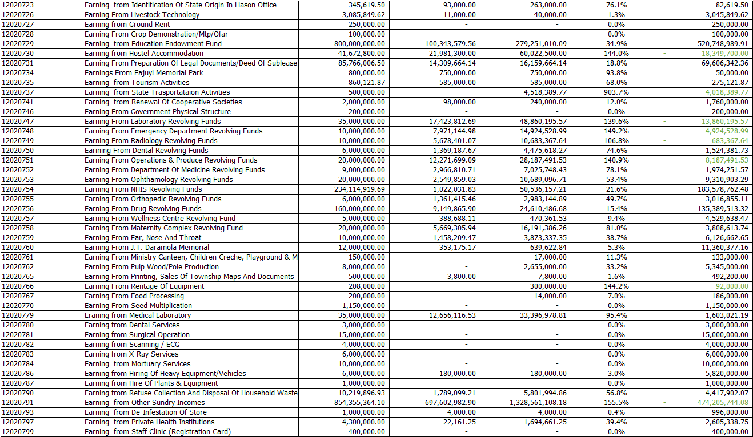



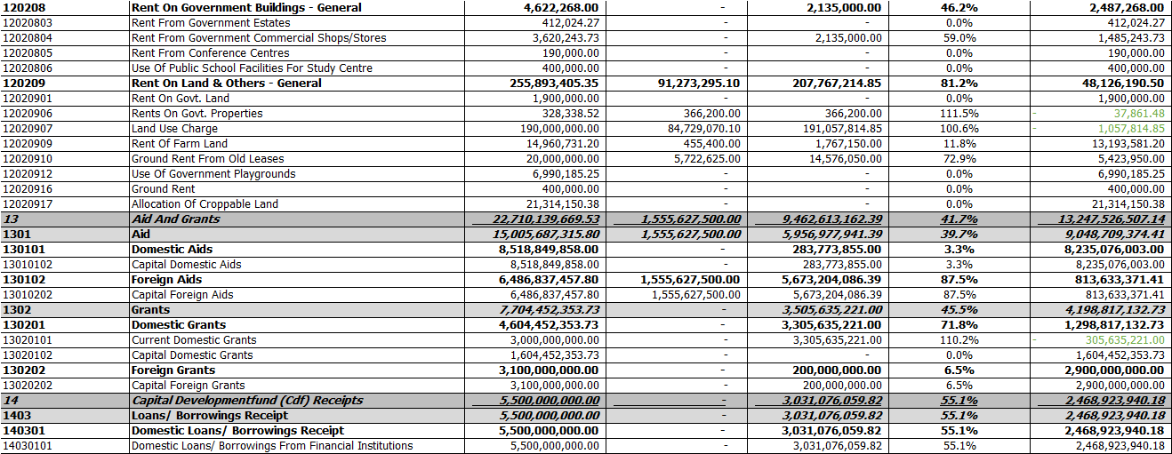

## Expenditure by Administrative Classification

Table : Total Expenditure by Administrative Classification

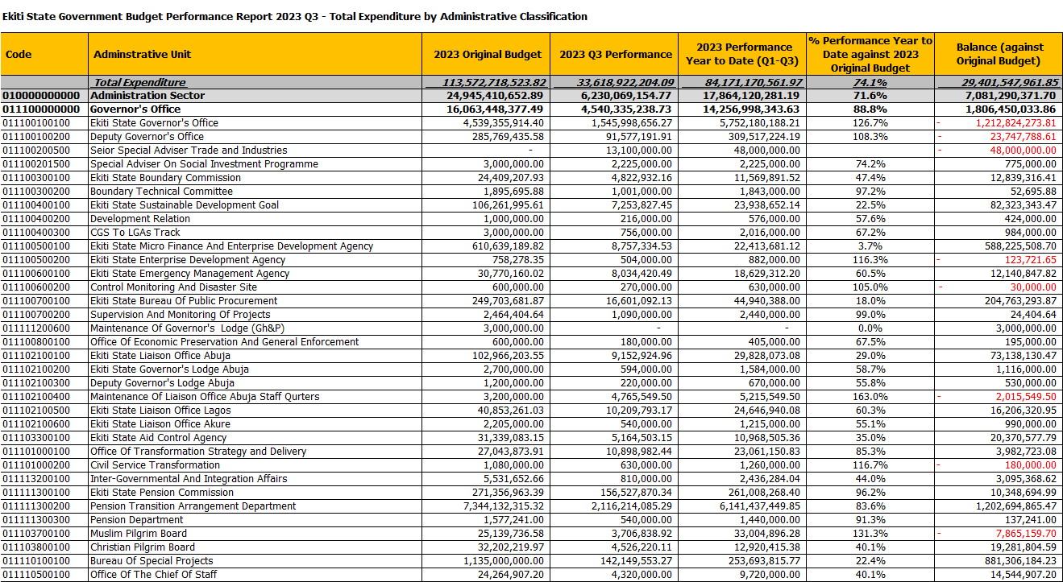



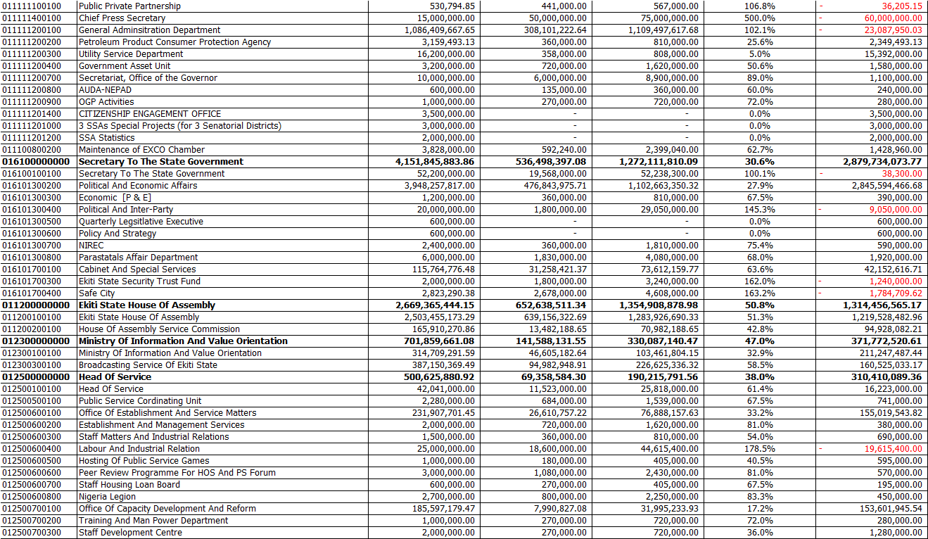



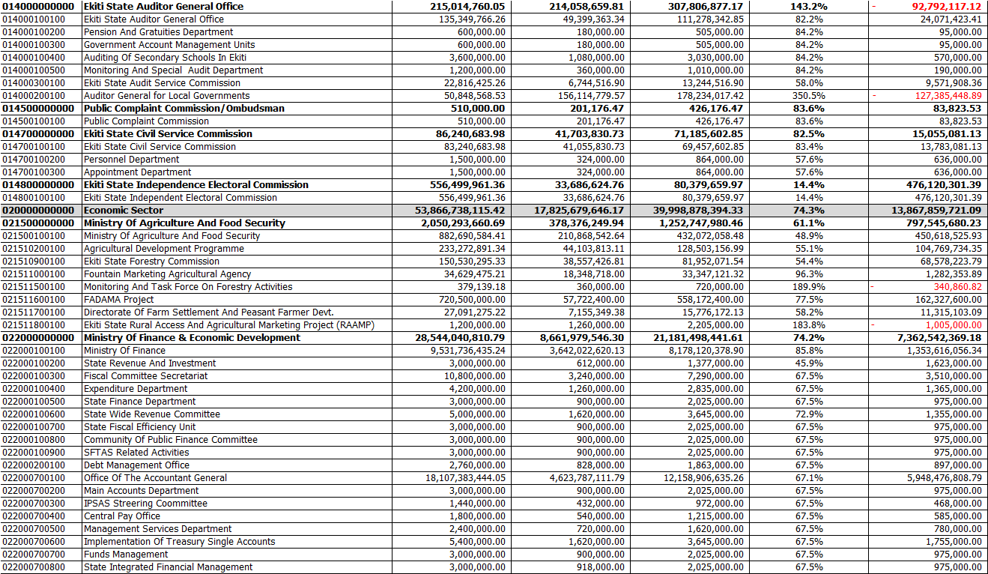



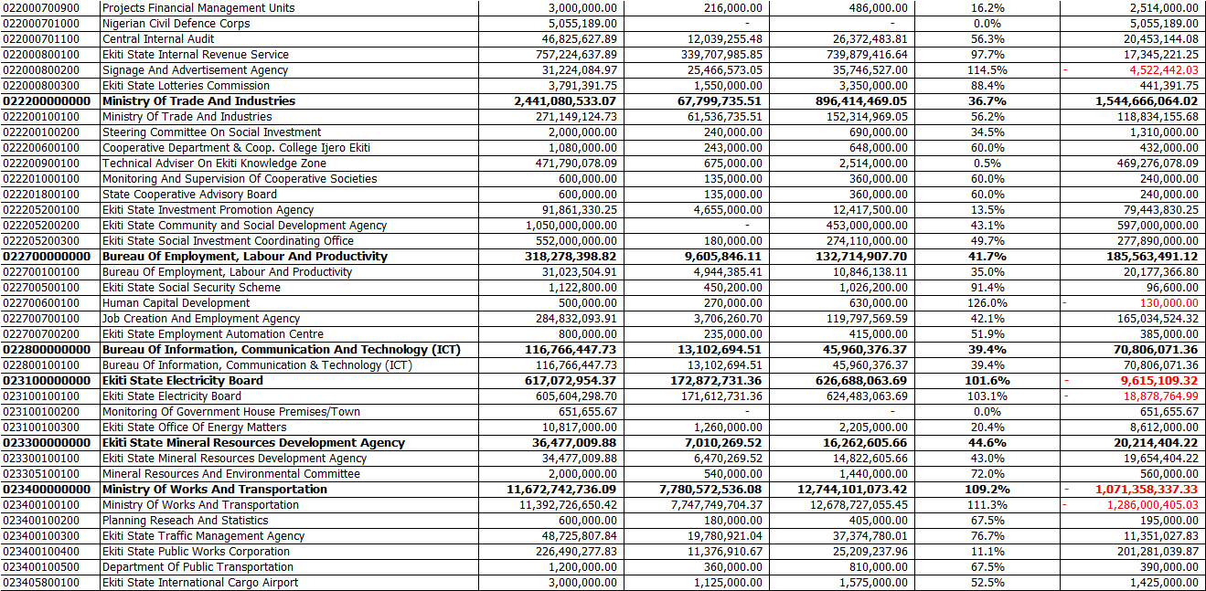



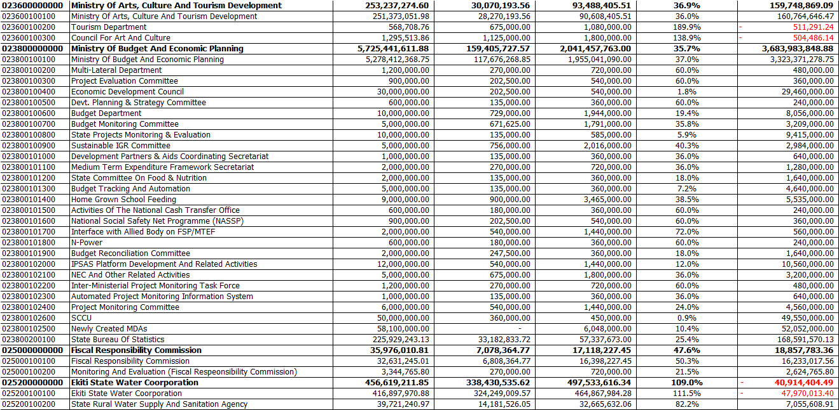



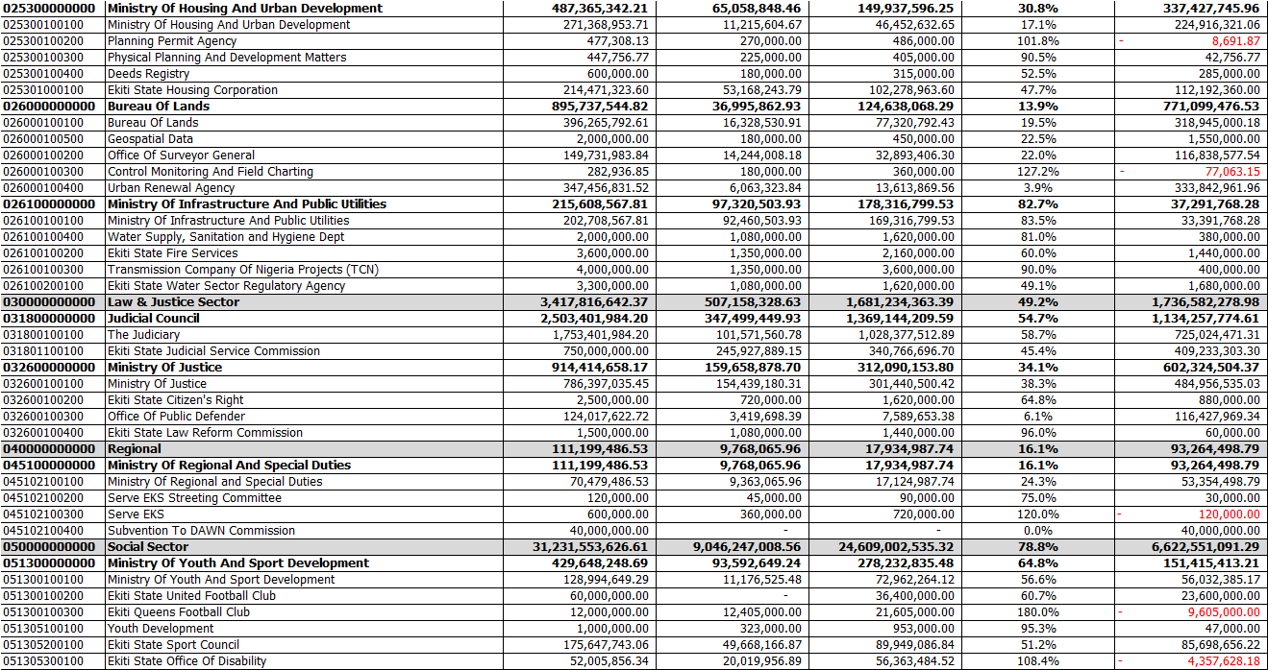



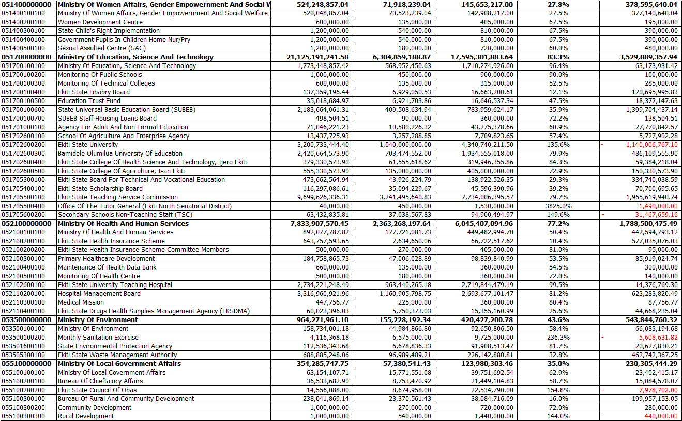

Table : Personnel Expenditure by Administrative Classification

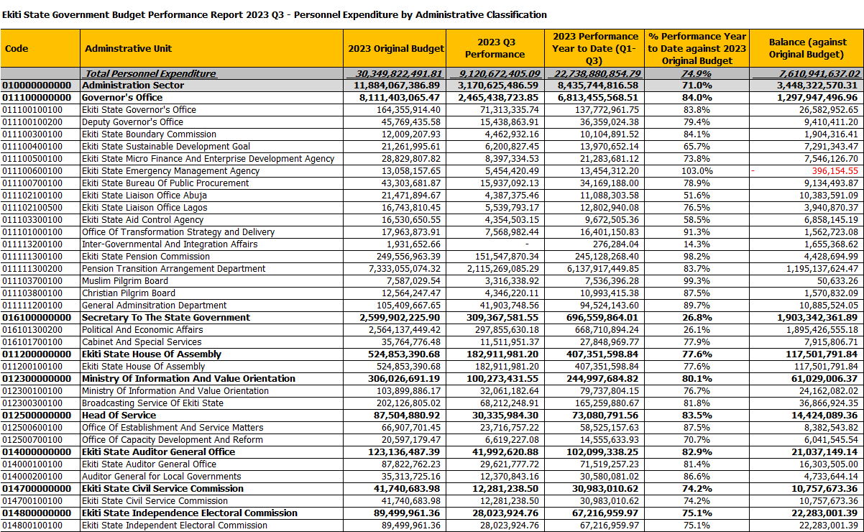

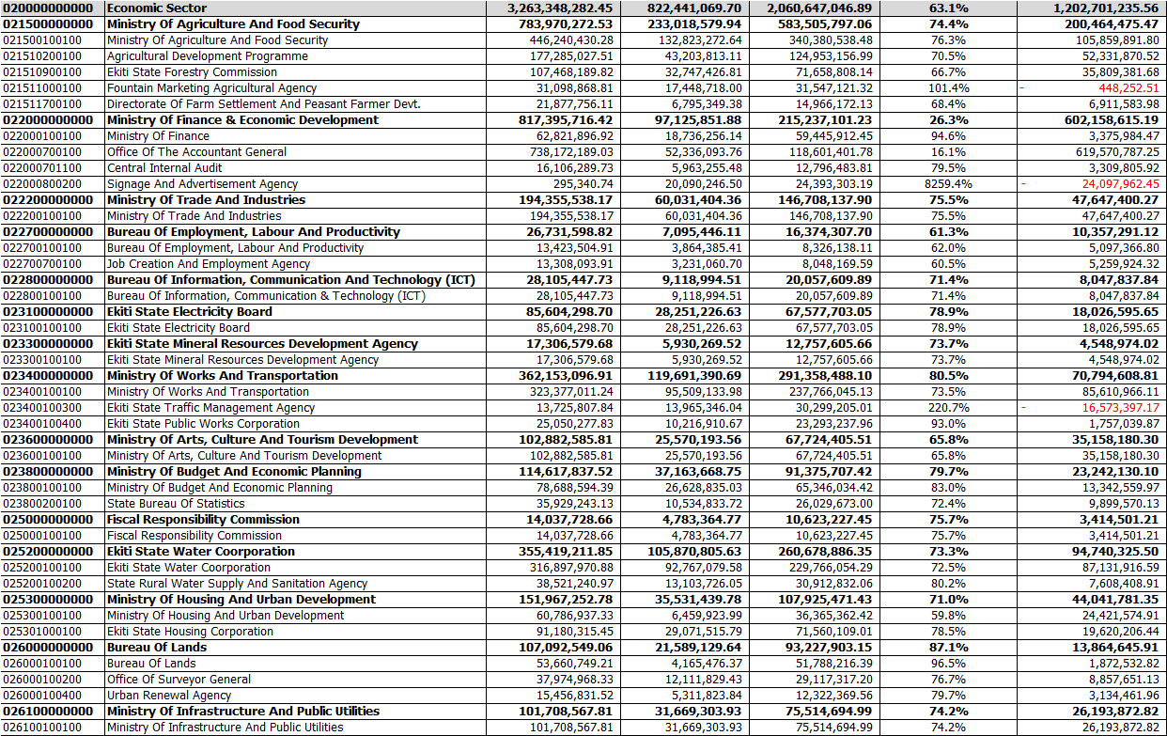

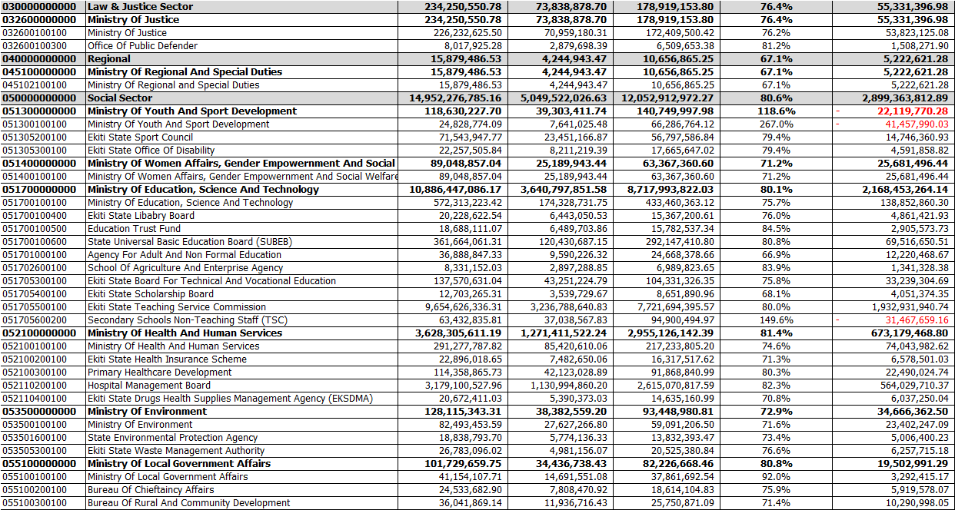

Table : Overhead Expenditure by Administrative Classification

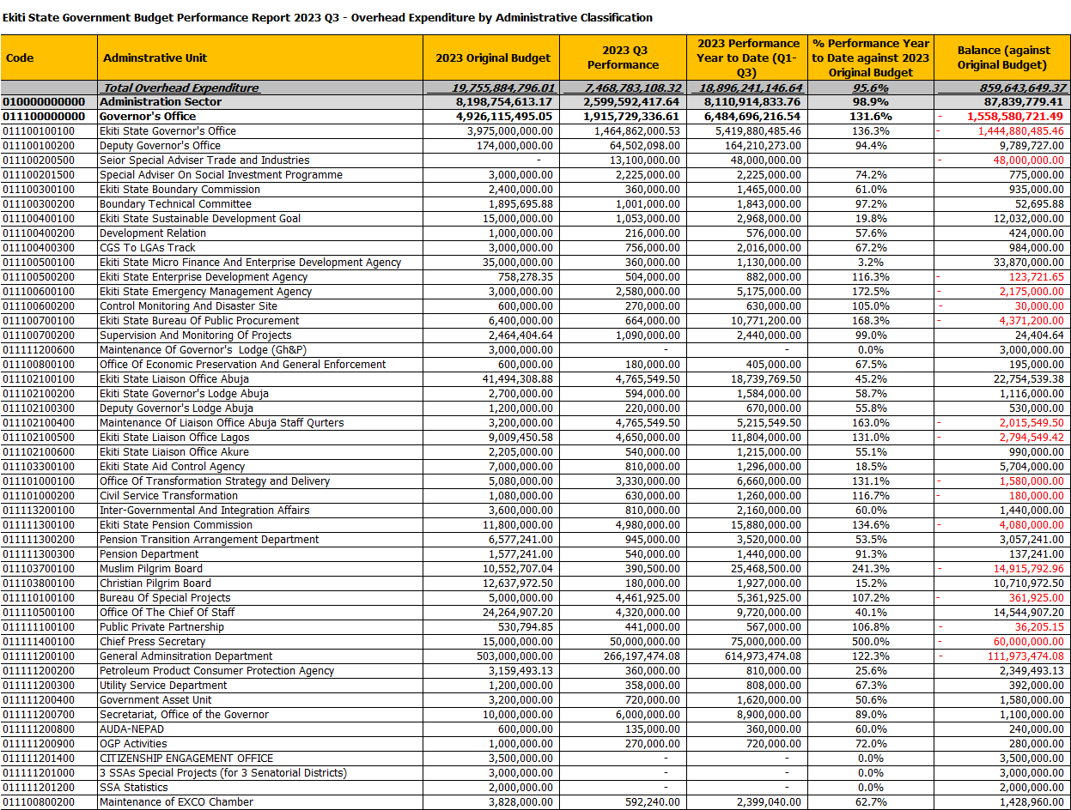

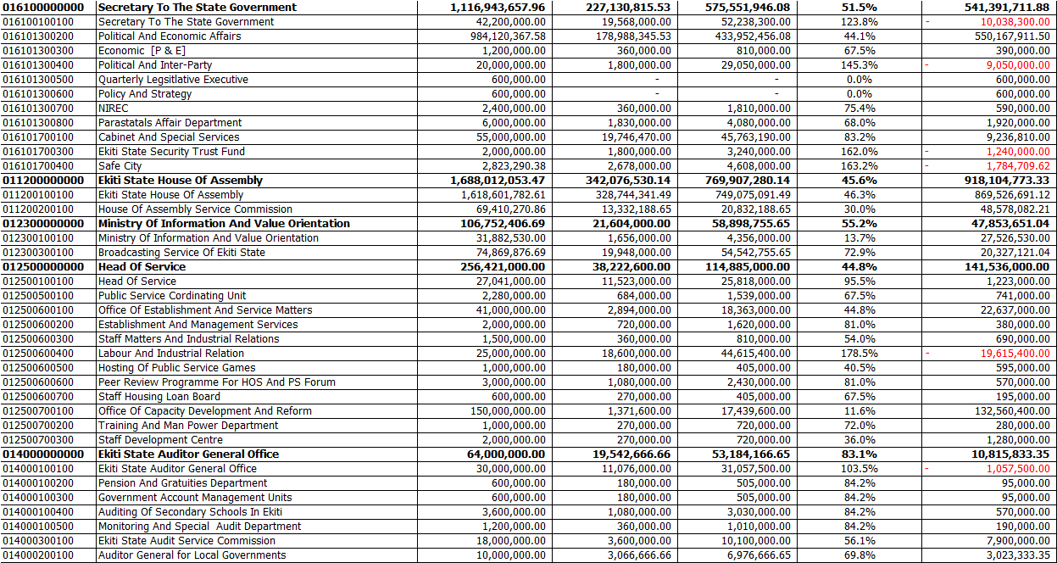

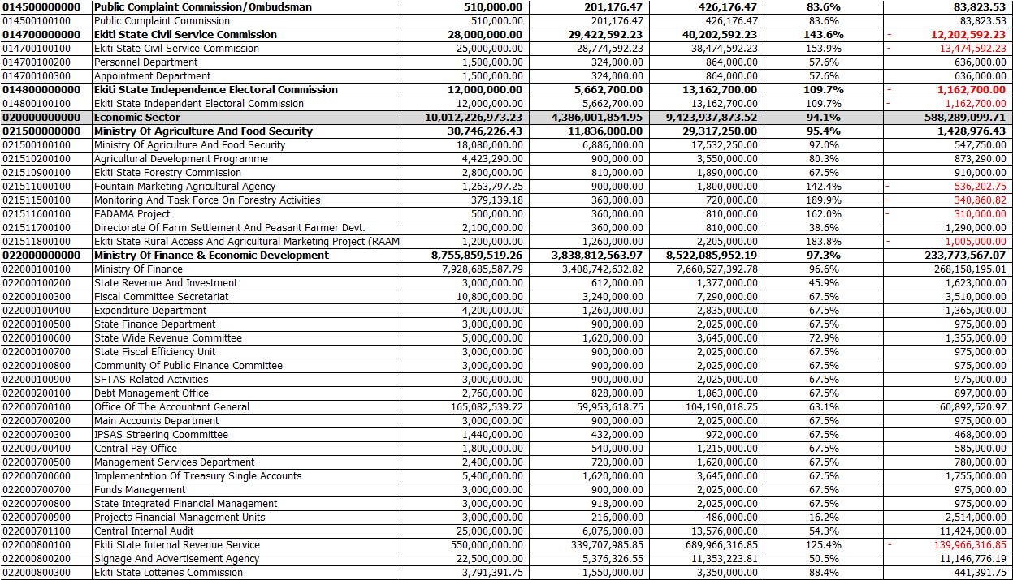

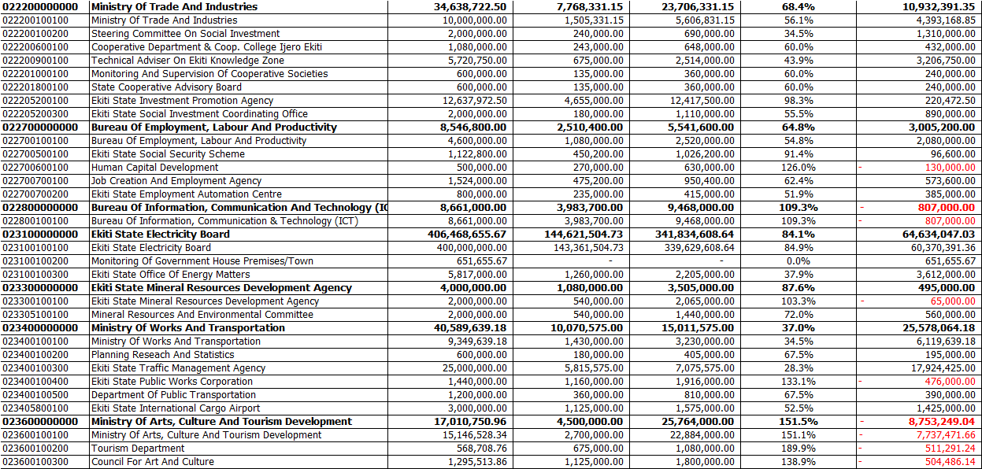

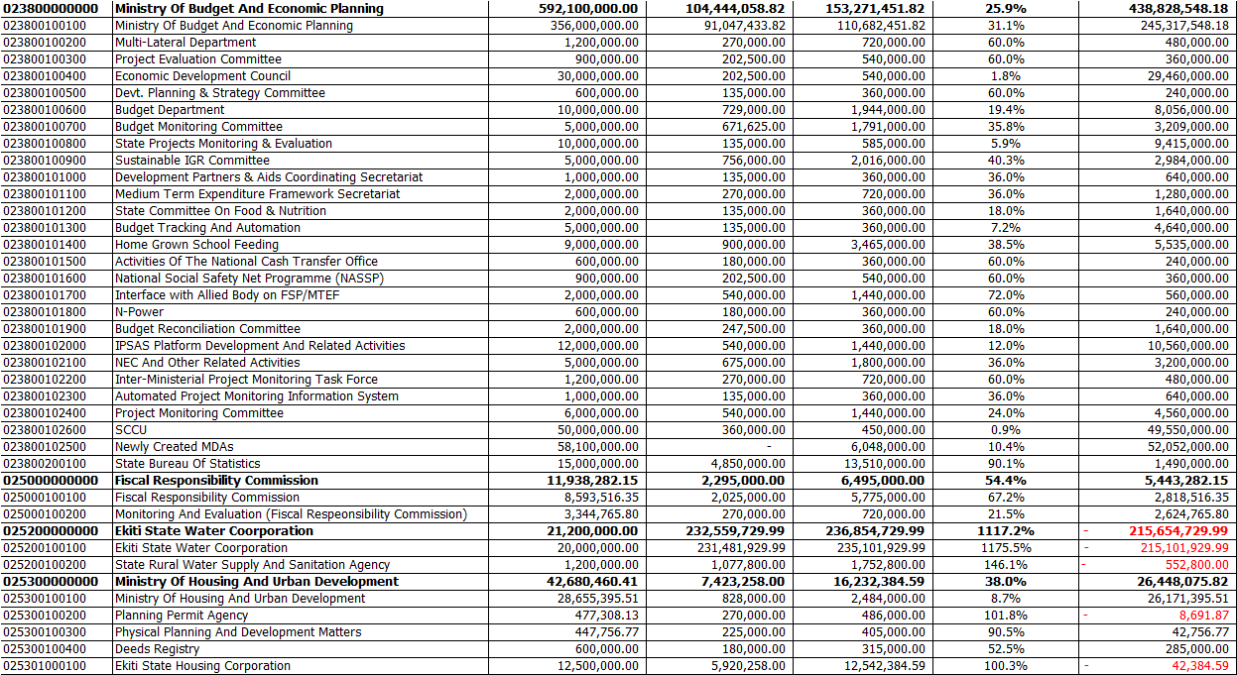

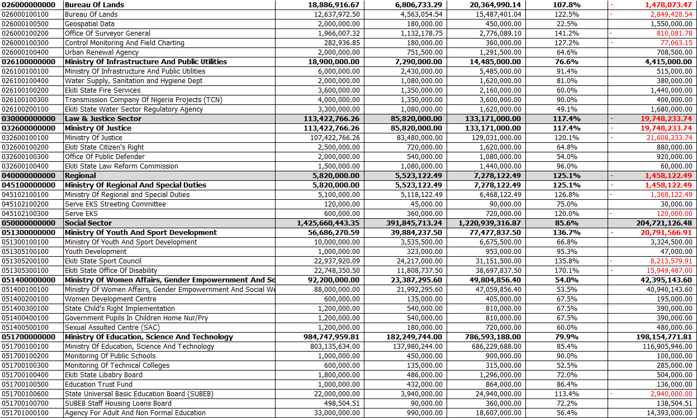

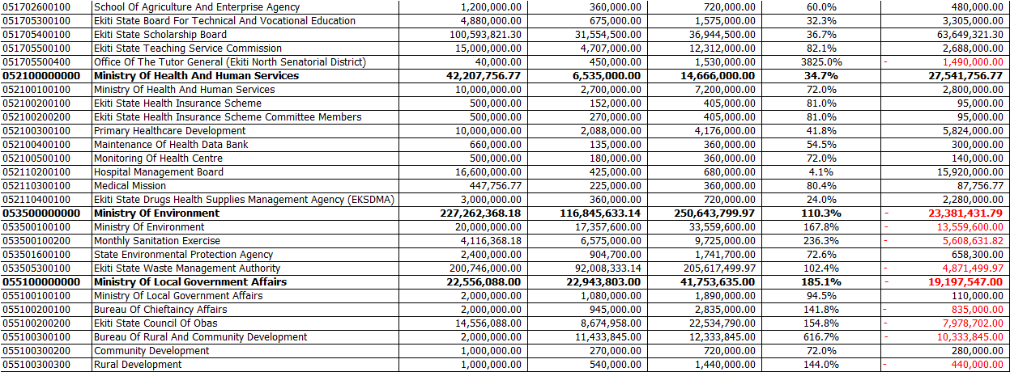

Table : Capital Expenditure by Administrative Classification

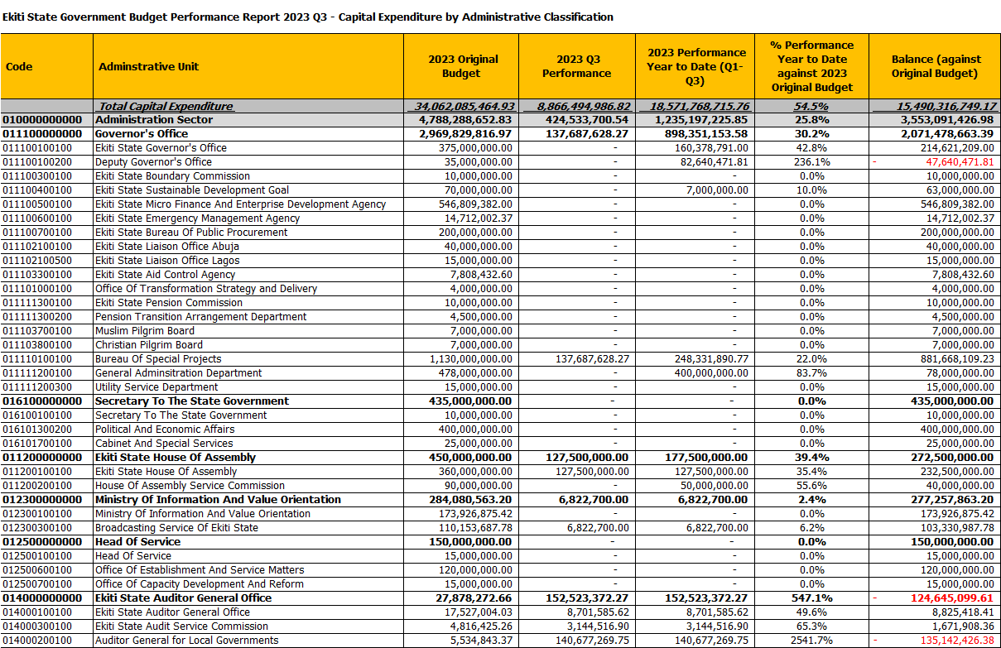

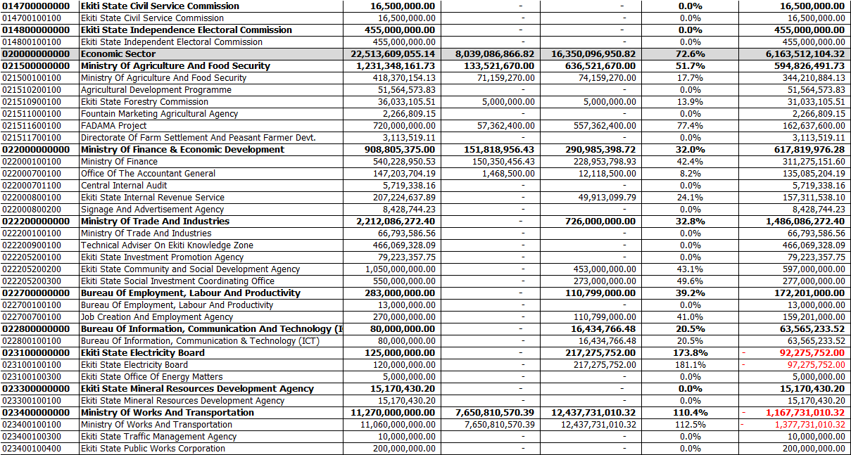

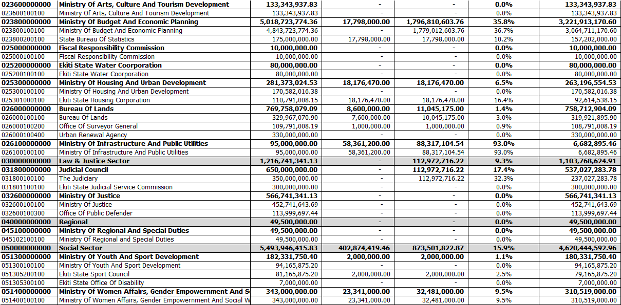

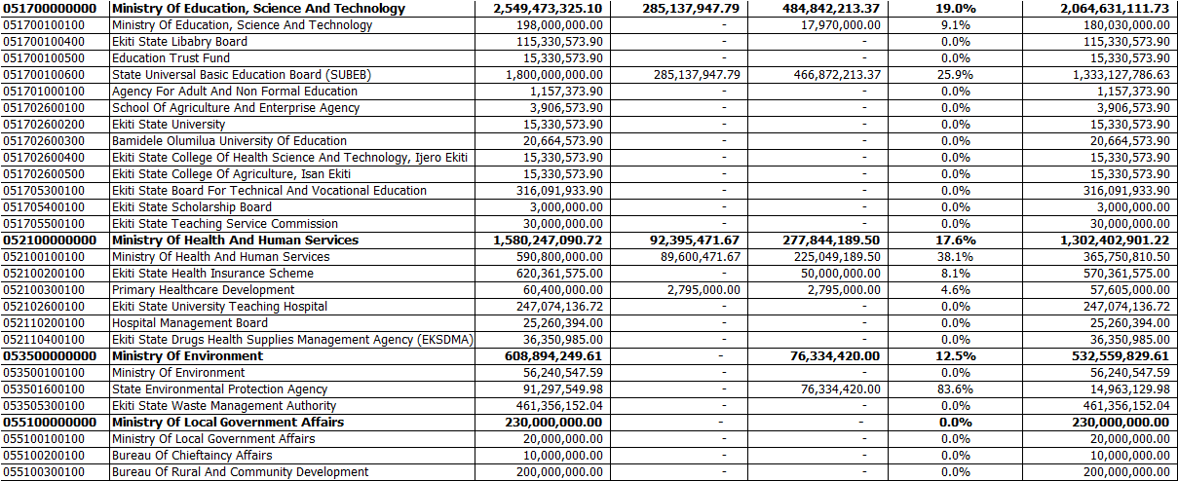

Table : Other Expenditure by Administrative Classification

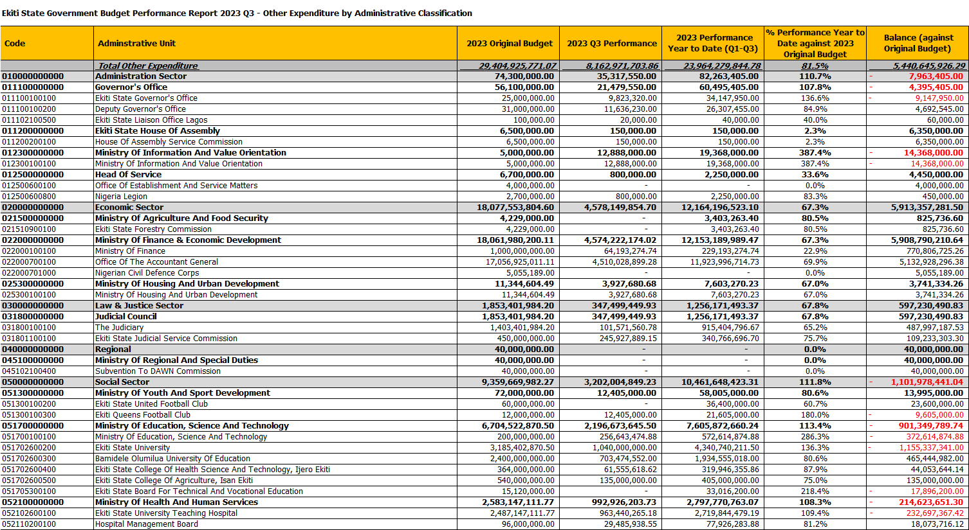

## Expenditure by Economic Classification

Table : Total Expenditure by Economic Classification



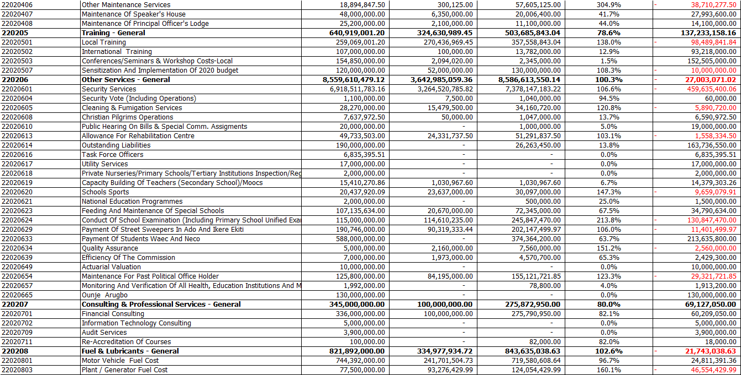

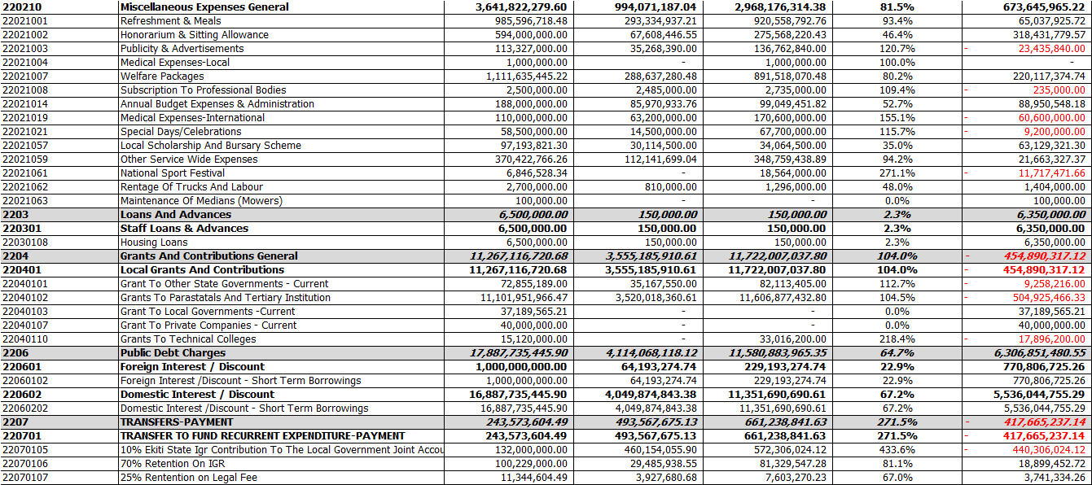



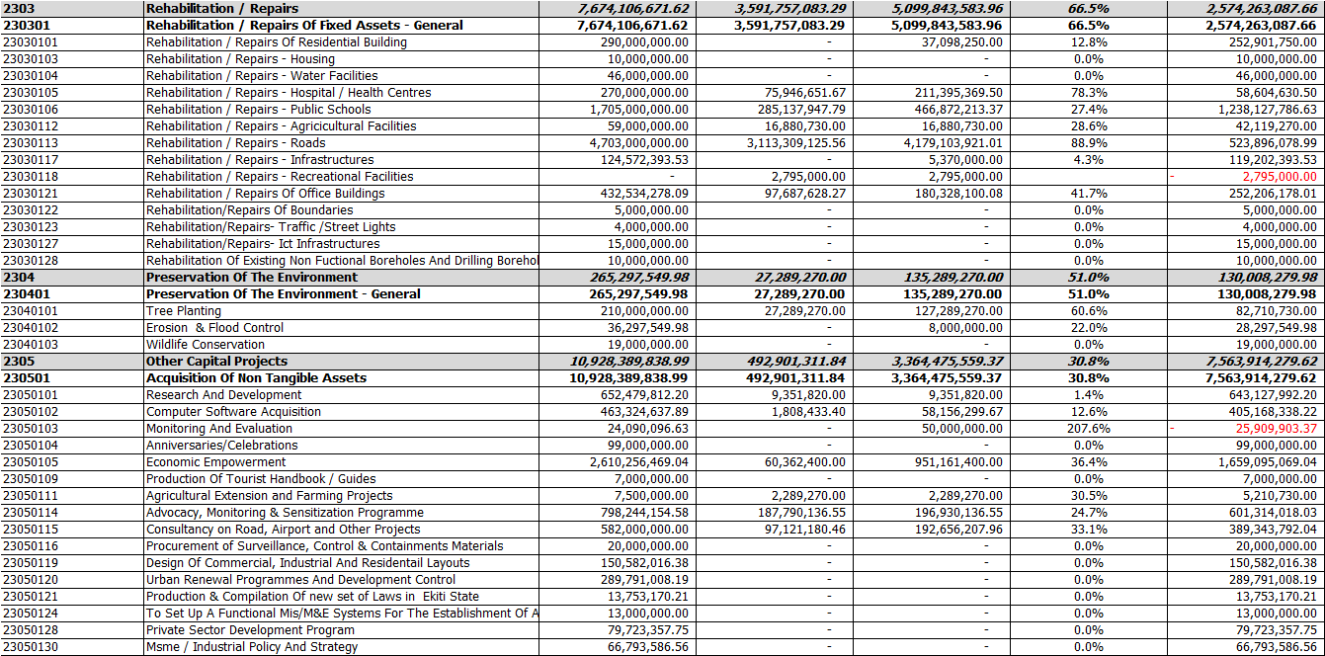



## Expenditure by Function

Table : Total Expenditure by Function

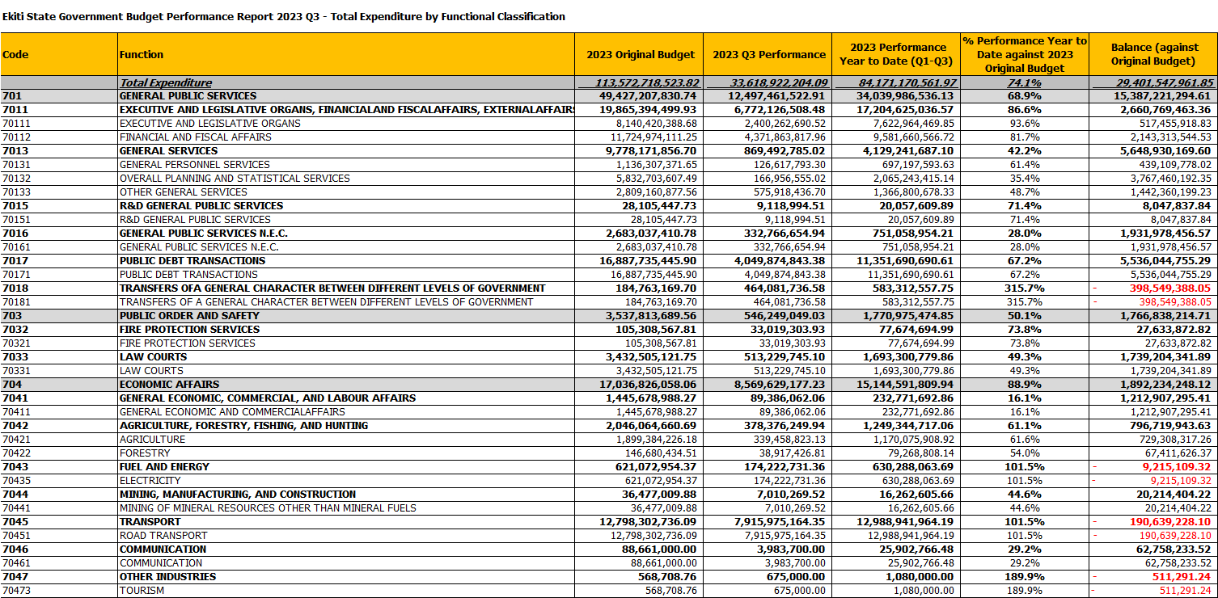

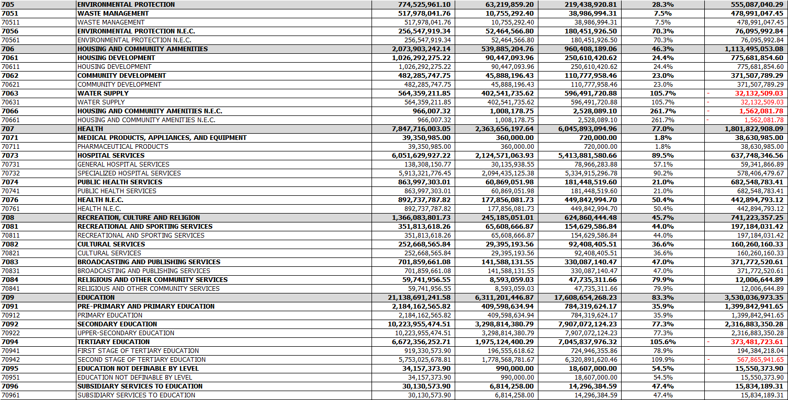

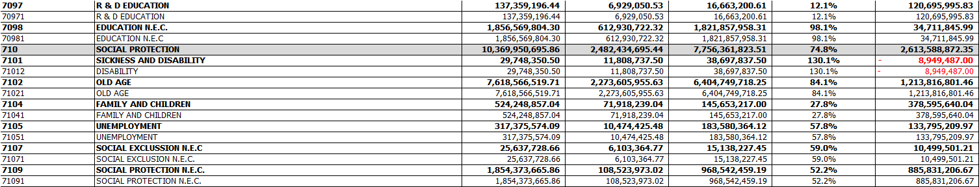

Table : Personnel Expenditure by Function

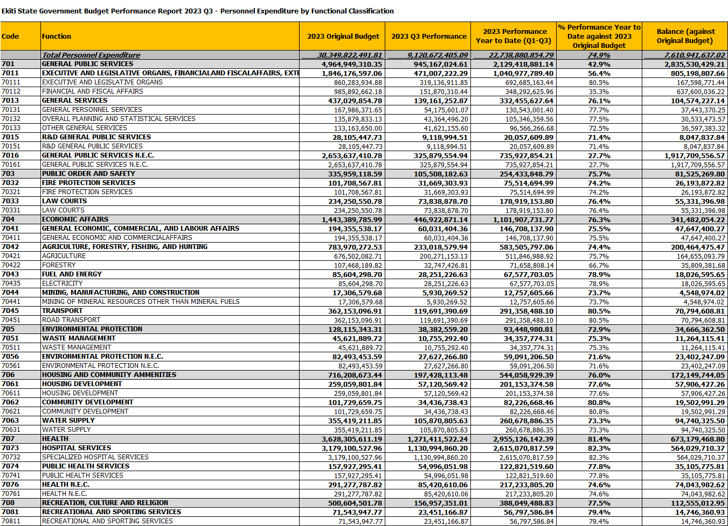

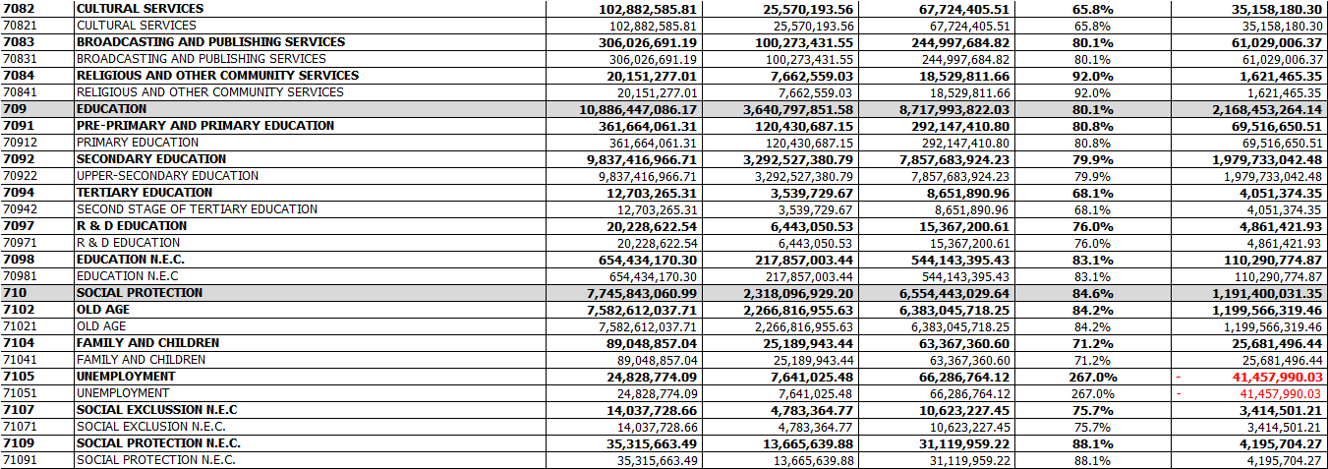

Table : Overhead Expenditure by Function

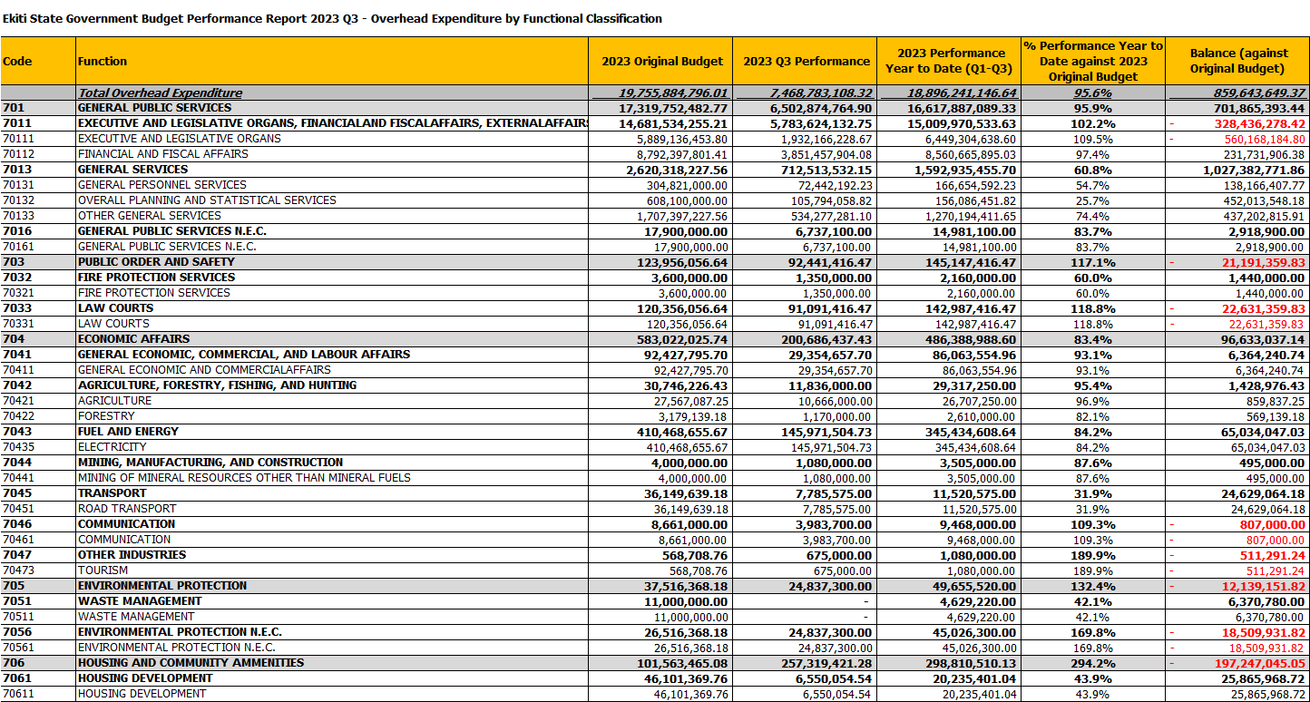



Table : Capital Expenditure by Function

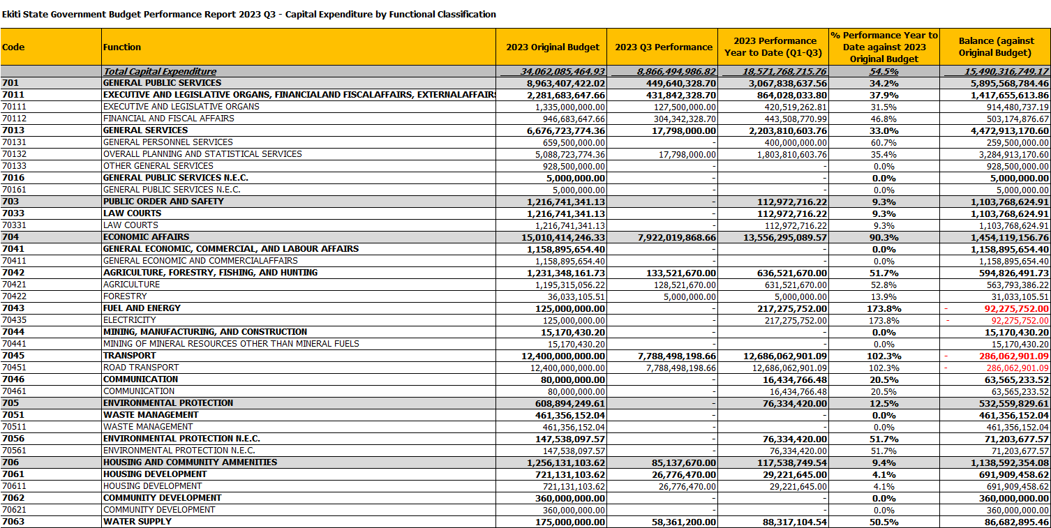

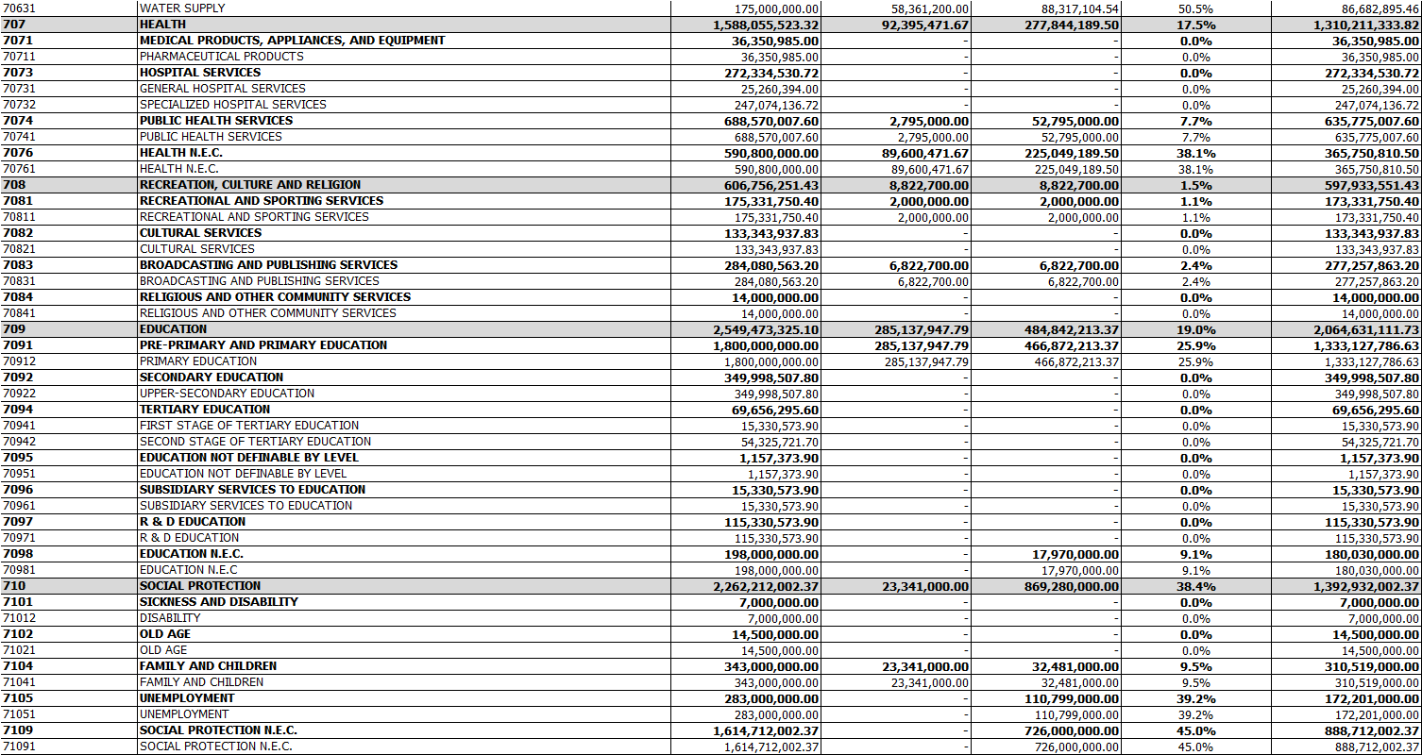

Table : Other Expenditure by Function

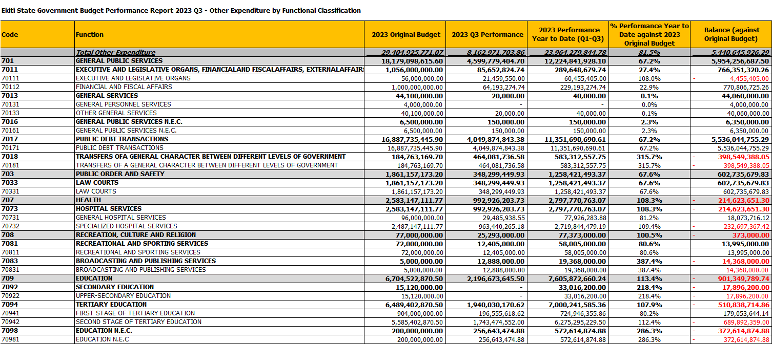

Table 15: Capital Expenditure by Projects

