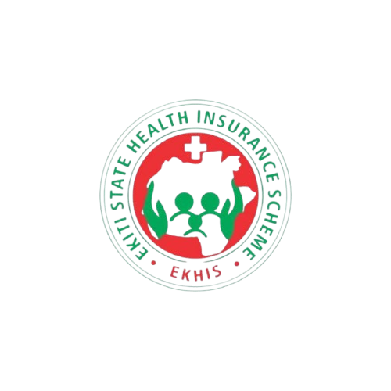

**Ekhis Ekiti State (Ekiti State Health Insurance Scheme)**

**ekhis_ekiti**

**@ekhis12**

1. **7064 010069**

**@.com**

**Ekiti State Health Insurance Scheme**

**2024 Annual Report**



**TABLE OF CONTENTS**

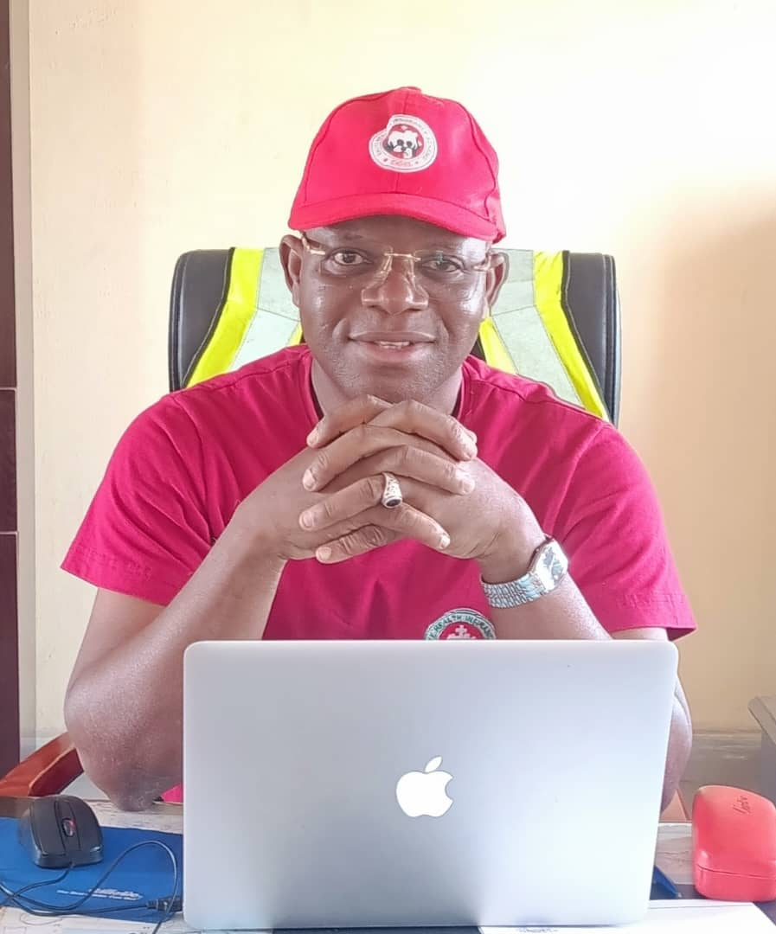

***Message from***

***General Manager***

**Message from**

**GM**

**The** ULERAWA program also experienced significant growth, with utilization climbing from 114,000 in 2023 to over 390,000 in 2024. This growth reflects the trust and confidence of the Ekiti State residents in our services.

**Enhanced Healthcare Delivery**: We have ensured that beneficiaries access quality healthcare across 177 PHCs, 21 secondary, and 3 tertiary health facilities in the state. Strengthened partnerships with healthcare providers and other agencies, such as the Ministry of Health and Human Services, Hospitals’ Management Board (HMB), State Primary Health Care Development Agency (SPHCDA), led to improved service delivery and health outcomes.

It is with great pride and a deep sense of responsibility that I present the 2024 Annual Report of the Ekiti State Health Insurance Scheme (EKHIS). This report highlights the significant progress we have made, the challenges we have faced, and our shared vision for the future.

The year 2024 has been transformative, marking substantial advancements in our mission to deliver accessible, affordable, and high-quality healthcare to all residents of Ekiti State. Through our equity programs, EKHIS has remained dedicated to broadening healthcare coverage, improving service delivery, and fostering partnerships for sustainable healthcare growth.

**Key Achievements**

**Growth in Enrollment and Utilization**: This year, we saw a remarkable increase in the enrollment of residents into the Basic Health Care Provision Fund Program, from 23,000 to 56,000, with service utilization rising from 75,000 in 2023 to approximately 100,000 by year-end.



**Driving Healthcare Excellence: Overview of the 2024 Annual Report**



we are committed to overcoming these obstacles through strategic planning and collaboration with key stakeholders.

**Looking Ahead**

Our future focus will be on expanding coverage and utilization, particularly in rural and underserved areas. We are also dedicated to enhancing the quality of services to ensure all Ekiti State residents have access to timely and effective healthcare.

**In Conclusion**

I express my deepest gratitude to the Ekiti State Government, led by Mr. Biodun Oyebanji, for its steadfast support of the scheme and its commitment to improving the health of our residents. I also acknowledge the exemplary leadership and resourcefulness of the Honourable Commissioner for Health and Human Services, Dr. 'Banji Filani.

My sincere thanks go to the House Committee on Health, under the leadership of Hon. Solanke, for their continuous advocacy, community mobilization, and support. I also appreciate the valuable contributions of other health sector accounting officers: Mrs. Olusola Gbenga-Igotun (PS, MOH&HS), Dr. Olasunkanmi Alabi (PS, HMB), Dr. Ayodele Seluwa (DG, SPHCDA), Pharm. Olufemi Oyeniran (GM, EKDHSMA), and Dr. Samuel Ojo (ES, SACA).

**Technological Innovations:** Upgrading and integrating our ICT infrastructure has revolutionized our operations. From digital enrollment to patient management, claims processing, and data-driven decision-making, we've embraced technology to boost efficiency and transparency.

**Community Engagement and Awareness**: Recognizing the importance of grassroots engagement, we intensified community outreach, advocacy, and radio programs. These initiatives have not only educated the populace on the benefits of health insurance but also nurtured a culture of health-seeking behavior.

**Improved Health Indices**: Significant improvements in Ekiti State's health indices, as reported in the National Demographic and Health Survey (NDHS) from 2019 to 2024, underscore the crucial role played by the Ekiti

State Health Insurance Scheme (ESHIS) in these achievements.

**Challenges**

Despite our successes, challenges remain. We continue to face issues such as a shortage of permanent technical staff, infrastructural deficits like inadequate office space, and the need for ongoing capacity building for focal persons and healthcare providers. Nonetheless,



I am grateful to the National Health Insurance Authority, led by Dr. Kelechi Ohiri, for their guidance and continuous support.

Special thanks to the directors and staff of EKHIS, our healthcare providers, and our partners, including CHAI, DPD, SOLINA, JHPIEGO, ECEWS, NSSF, GIZ, LOTUS, NOIPOLLS, and all stakeholders, for their unwavering dedication. Together, we will continue to build a robust health insurance system that serves as a model for others.

Thank you for your continued support.

***Charles Olusegun Doherty***

***General Manager***



***VISION &***

***MISSION***



**VISION &**

**MISSION**



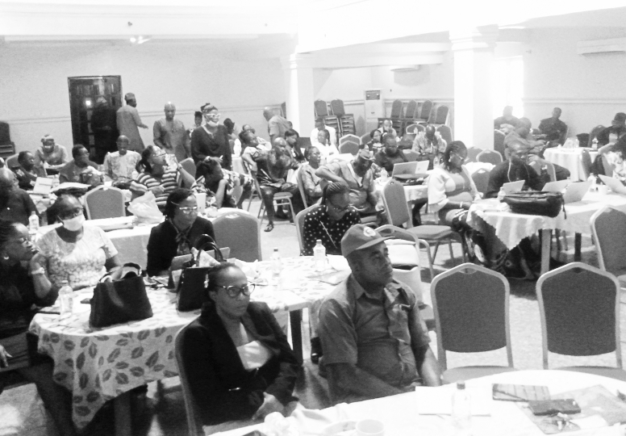**ORGANOGRAM**

**Our Vision:**

Accessible Healthcare for Ekiti Residents

**Mission:**

To put in place appropriate health plans and programs that will ensure access of all Ekiti residents to qualitative and affordable health care services through collective pooling and redistribution of financial resources.

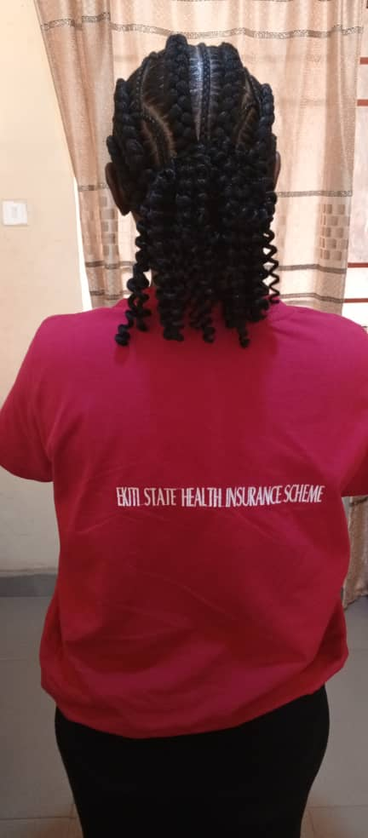



**Organogram**

**EKHIS Committee**

**Claims verification**

**Final Account**

**Treasury**

**Disbursement**

**Advocacy & Sensitization**

**Enrollment**

**Accreditation**

**Call centre**

**Authorization code**

**Finance & Account**

**M&E**

**plans & budget**

**Programme**

**Standard Quality Assurance**

**Gen . Admin**

**HR**

**store**

**Planning, Research & Statistics**

**Admin & Supply**

**General Manager**

**ICT**

**Social Mobilization**

**Internal Audit**

**final acct.**

**Hardware**

**Software**

**HMIS**

**Research &Publications**

**ICT**

**Trainning**

**Social Mobilization**

**Internal Audit**



***Department of***

***Planning Research***

***and Statistics***

**Department of Planning Research and Statistics**



### *****Achievements*****

#### ****Data Collection and Analysis****

* Collected, validated, and analyzed data from **2** major programs (BHCPF and UILERAWA), focusing on demographics, disease prevalence, healthcare utilization, and patient outcomes.
* Utilization for BHCPF increased from **75,000** in 2023 to **102,000** in 2024, while utilization for UILERAWA rose from **114,000** to **390,000**.
* Conducted **17** data analyses to support evidence-based decision-making and policy formulation with high-quality data insights



***Introduction***  
The Department of Planning, Research, and Statistics in the Ekiti State Health Insurance Scheme has been pivotal in enhancing healthcare services through data-driven insights and strategic initiatives. This report outlines the department’s key achievements, challenges, and future plans over the past year, showcasing its commitment to improving public health outcomes in Ekiti State.

### *****Mandates*****

The department is responsible for:

* Collecting and analyzing health-related data.
* Conducting research to inform policy decisions.
* Developing strategic plans for the Agency.
* Facilitating collaborations with key stakeholders.
* Monitoring and evaluating healthcare programs and initiatives.



#### *****Research Initiatives*****

* Participated in **three (3)** research projects to address critical health challenges:
  + Willingness and Ability to Pay

for Health Insurance by Ekiti citizens.

* Community Health Network Mapping and Assessment of Barriers to Healthcare and Health Insurance.
* Evaluation of Factors Influencing Decline in Facility-Based Deliveries in Ekiti State conducted in collaboration with DPD, LOTUS, and NOIPolls.
* These studies provided actionable insights, contributing to targeted interventions and programs.

**Strategic Planning**

* Contributed to the development and validation of 2024 Annual Operational Plans for Ekiti State, enhancing healthcare delivery, resource allocation, and infrastructure development.

**Collaboration and Partnerships**

* Strengthened partnerships with **12** key stakeholders, including MOH&HS, HMB, SPHCDA, research institutions, and government agencies.
* Participated in **4** gateway meetings with SPHCDA and 3 SOC meetings on BHCPF programs.

#### ****Monitoring and Evaluation (M&E)****

* Conducted 2 comprehensive M&E activities across all **16** LGAs in the state.
* Presented detailed M&E reports in **4** forums, including Integrated Review Meetings and SOC meetings, to enable timely and informed decision-making.

#### *****Validation Exercises and Review Meetings*****

* Conducted 12 monthly validation exercises and review meetings to ensure data accuracy and reliability from primary healthcare centers (PHCs).

#### *****Capacity Building*****

* Participated in six (6) capacity-building initiatives.

***Ogunyemi Oyeyemi***

***Director, Planning Research and Statistics***



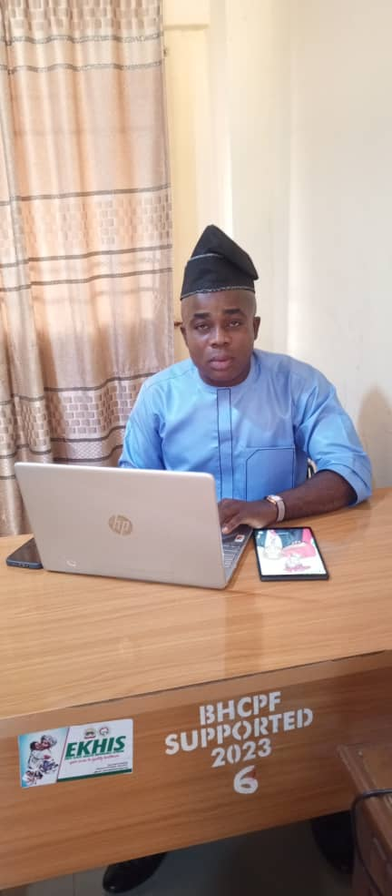

***Department of***

***Programme***





* Verifying and validating enrollees to maintain data integrity and prevent fraud.

**3. Achievements**

**3.1 Enrollment Expansion**  
The Program Department enrolled an additional 36,560 beneficiaries, bringing the total number of enrollees to:

* **Basic Health Care Provision Fund (BHCPF):** 57,560

Targeted outreach efforts focused on pregnant women, children, people with disabilities, the elderly, and other vulnerable groups.

**Introduction**  
The Annual Comprehensive Report of the Programs Department in Ekiti Health Insurance Schemes (EKHIS) for 2024 highlights the department’s strides in improving health insurance coverage and service delivery. EKHIS is committed to providing accessible and affordable healthcare to the residents of Ekiti State. In 2024, the Program Department achieved significant milestones in expanding enrollment, enhancing healthcare access, and strengthening partnerships with stakeholders.

**2. Mandate**  
The Programs Department of EKHIS is tasked with implementing policies and strategies to achieve the scheme’s goal of Universal Health Coverage (UHC). This involves:

* Increasing enrollment, especially among vulnerable populations.
* Strengthening community awareness and mobilization for health insurance.
* Enhancing service delivery through improved partnerships with healthcare providers.
* Ensuring financial sustainability and operational efficiency through innovative funding and capacity building.



**Department of Programme**

\

**3.3 Verification and Validation**  
Verification and validation ensured the accuracy and integrity of enrollment data:

|  |  |  |  |
| --- | --- | --- | --- |
| **S/NO** | **INDICATOR** | **TOTAL NUMBER** | **% DISTRIBUTION** |
| 1 | Confirmed enrollees | 53,819 | 93.5% |
| 2  3 | Unreached enrollees | 1524 | 2.8% |
| 4 | Relocated enrollees | 2041 | 3.5% |
| 5 | Deceased enrollees | 138 | 0.2% |
|  | **Total Verified** | **57,560** | **100%** |

**BHCPF ENROLMENT.**

|  |  |  |  |
| --- | --- | --- | --- |
| S/NO | STATUS | ENROLLMENT % | TOTAL ENROLLED |
| 1 | Pregnant women | 26 | 14,965 |
| 2 | Children under 5 | 35 | 20,146 |
| 3 | People with disabilities | 09 | 5,181 |
| 4 | Reproductive Age | 10 | 5,756 |
| 5 | Elderly | 10 | 5,756 |
| 6 | Indigent | 10 | 5,756 |
|  | Total | 100 | 57,560 |

**3.2 Community Mobilization Campaigns**

* Conducted 5 campaigns involving local health workers and leaders to raise awareness, leading to a 35% increase in enrollment.
* Accredited 177 healthcare providers, ensuring broad service accessibility across the state.

**Conclusion**  
In 2024, the Programs Department of EKHIS significantly advanced its mission to achieve Universal Health Coverage. Through targeted enrollment efforts, capacity building, community engagement, and technological advancements, the department enhanced access to quality healthcare for Ekiti residents. These achievements underscore EKHIS’s commitment to sustainability and continuous improvement in healthcare delivery.

*****MLS Gbenga Oluwabunmi Ogundero*** *Director of Programs***

**Capacity Building**

**Staff Training:**

* WHO e-learning course on Health Financing.
* Training on procurement procedures.
* On-site training on health financing in Nigeria supported by CHAI.
* In-house training on strategic administration and financial management for sustainable health insurance programs.

**Community Health Workers (CHWs):** Focused training enhanced their capabilities in health insurance literacy and basic healthcare delivery.

**Advocacy and Community Mobilization**

* Advocacy visits to local leaders and healthcare providers fostered trust and collaboration.
* Community mobilization campaigns, in partnership with NGOs and media, improved public awareness and enrollment rates.
* The use of media, brochures, and health fairs successfully increased understanding of health insurance benefits across Ekiti State.



**3**



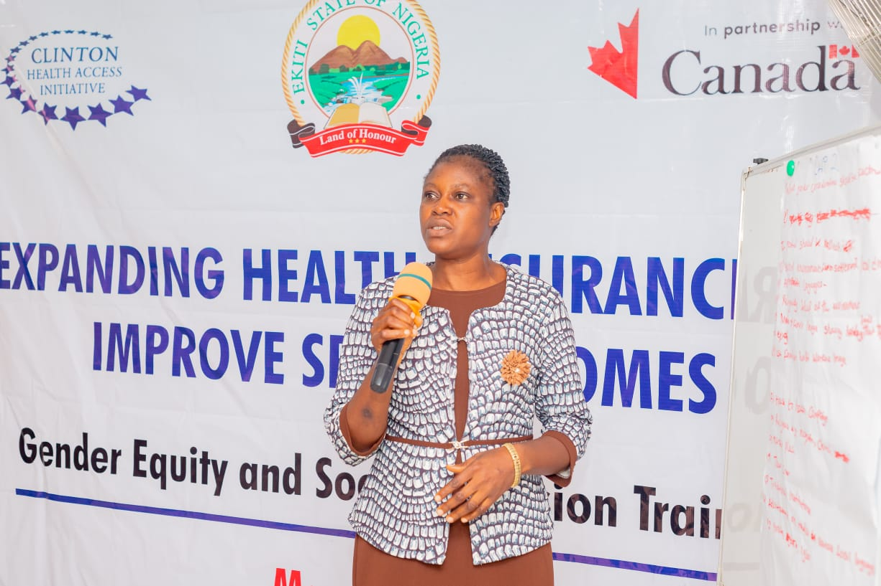

***Department of***

***Quality Assurance***





**Standardization & Quality Assurance**

* Developed referral guidelines, audited claims, and conducted quality assessments.
* Actively supported the free surgery program initiated by the State Governor.

**Capacity Building**

Mentored 22 facilities on claims management to reduce errors.

**Enhanced Feedback Mechanisms**

* Established a call center, handling 35,864 calls:
* **60%** resolved, **30%** addressed, **10%** unresolved due to non-covered treatments.

**Introduction**  
This report reviews healthcare delivery under the Basic Health Care Provision Fund (BHCPF) in 2024, summarizing clinical outcomes, diagnoses, treatments, referral system improvements, and quality assurance initiatives.

### ****Mandate****

1. **Quality Improvement**: Enhance healthcare quality through strategic interventions.
2. **Patient Safety**: Promote safety initiatives and risk minimization.
3. **Training**: Build capacity through training and mentorship for healthcare staff.
4. **Standards Compliance**: Regular assessments to meet healthcare guidelines.

### ****2024 Achievements****

**Referral System & Patient Care**

* 1. Issued 2,283 referral codes, facilitating care for 2,258 patients at 22 secondary facilities.
  2. Supported over 1,009 surgeries, averaging ₦226,035 per procedure.

**Department of Quality Assurance**



### ****Summary of Diagnoses and Treatments:****

The following table presents the distribution of various diagnoses and treatments reported by the health facilities for the year 2024:

| **Diagnosis** | **Total Cases** | **Percentage of Total (%)** |
| --- | --- | --- |
| (Caesarean Section) | 300 | 13.3% |
| (Malaria) | 59 | 2.6% |
| (Normal Delivery) | 192 | 8.5% |
| (Thyroid Conditions) | 2 | 0.1% |
| (Evacuation) | 12 | 0.5% |
| (Peptic Ulcer) | 8 | 0.4% |
| (UTI) | 7 | 0.3% |
| **HERNORRAPHY** | 113 | 5.0% |
| **Neonatal Asphyxia** | 15 | 0.7% |
| **HYSTERECTOMY** | 78 | 3.4% |
| **CATARACT Extraction** | 83 | 3.7% |
| **HYDROCELETOMY** | 34 | 1.5% |
| **APPENDIX** | 35 | 1.5% |
| **BATHORLIN CYST** | 3 | 0.1% |
| **Vaso-Occlusive Crisis** | 115 | 5.1% |
| **DM** (Diabetes Mellitus) | 13 | 0.6% |
| **HTN** (Hypertension) | 40 | 1.8% |
| **IUFD** (Intrauterine Fetal Death) | 3 | 0.1% |
| **GLAUCOMA** | 57 | 2.5% |
| **ORCHIDEXY** (Orchidectomy) | 11 | 0.5% |
| **PTERYGIUM** | 25 | 1.1% |
| **ENT** (Ear, Nose, Throat) Conditions | 40 | 1.8% |
| **URTI** | 15 | 0.7% |
| **TONSILITIS** | 32 | 1.4% |
| **OTHERS** | 191 | 8.4% |
| **DEATH** (Mortality) | 19 | 0.8% |
|  | 742 |  |



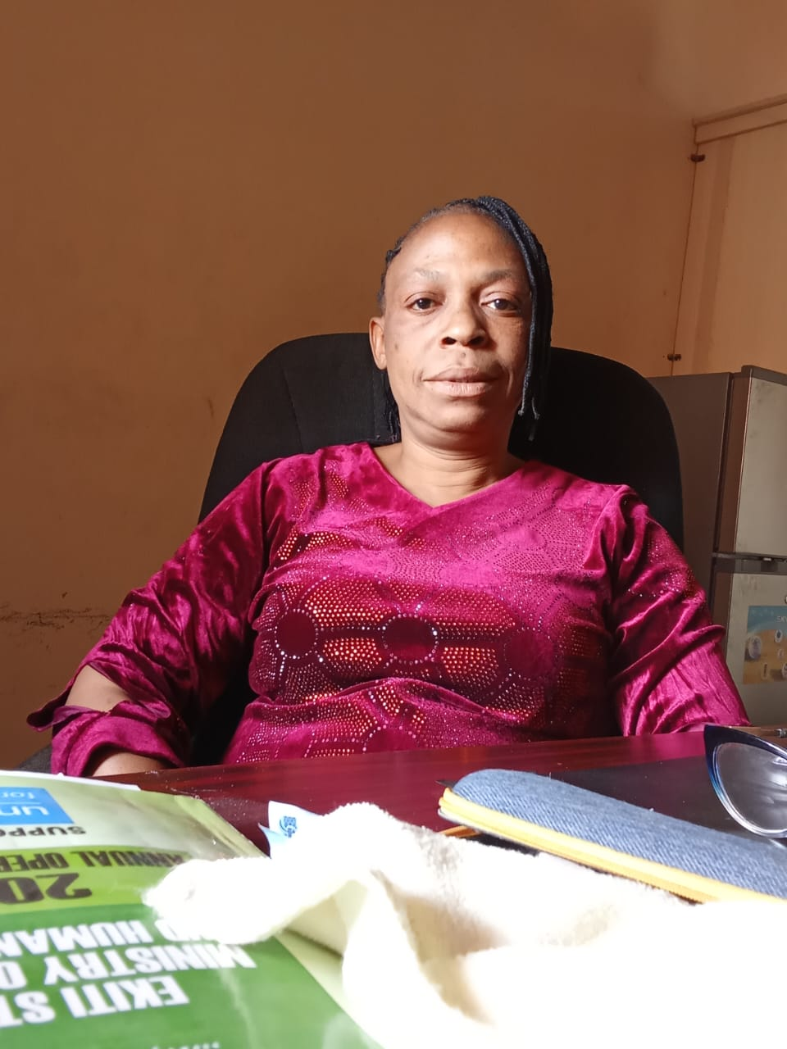

***Department of***

***Admin and Supply***



**WHO E-Learning Course:** Staff participated in the WHO Health Financing Course on Universal Health Coverage (UHC), strengthening their knowledge of health financing mechanisms.

**Health Financing Training:** Conducted training sessions to enhance staff expertise in financial sustainability and effective health insurance management.

These initiatives significantly contributed to staff development, empowering them to navigate the complexities of health insurance administration more effectively.

**2. Human Resource Management**

**Temporary Staffing:** Engaged six temporary staff members to support operational efficiency and address the increasing demands of the Scheme.

**Introduction**  
The Department of Administration and Supply of the Ekiti State Health Insurance Scheme (EKHIS) plays a pivotal role in ensuring the efficient management of resources, human capital, and procurement processes. In 2024, the department focused on capacity building for staff, optimizing operational efficiency, and addressing procurement needs to support the Scheme’s continued growth and effectiveness.

**Mandate**  
The department is responsible for providing administrative and logistical support, overseeing human resource management, and ensuring the timely procurement of essential supplies. These efforts facilitate the seamless implementation of EKHIS programs, ultimately enhancing service delivery.

**Key Achievements**

**1. Capacity Building.**

**In-House Training:** Organized a workshop on Strategic Administration and Financial Management for Sustainable Health Insurance Programs, equipping staff with essential skills to enhance operational efficiency.

### das 4

**Department of Admin and Supplies**



**5. Memo Writing and Documentation**  
Maintained high standards in memo writing, ensuring clear, professional, and effective communication to support administrative functions and operational efficiency.

Through these concerted efforts, the Department of Administration and Supply has strengthened the overall operational framework of EKHIS, playing a crucial role in the Scheme’s success in 2024.

**Mrs. Adeyemo Grace**  
Director of Administration and Supply

**Promotions:** Facilitated the promotion of eligible staff for the year 2022 and 2023

**3. Procurement Initiatives**

**Communication Tools:** Acquired 6 televisions for departmental presentations and 3 mobile phones for the call center to improve communication, training, and customer service.

**Document Management:** Procured 3 shelves to enhance document storage, ensuring better organization and accessibility.

**Operational Materials:** Supplied hospital cards and informational posters to facilitate public awareness campaigns and improve service delivery.

These strategic procurement have significantly enhanced the operational efficiency of EKHIS, benefiting both staff and Scheme beneficiaries.

**4. Meetings and Decision-Making**  
The department successfully coordinated 10 meetings throughout the year, fostering effective communication and strategic decision-making aligned with the objectives of EKHIS.





### ****INTRODUCTION****

The Internal Audit Division of the Ekiti State Health Insurance Scheme is tasked with ensuring an effective internal control system across all sections of the Agency. In line with this responsibility, the Internal Audit Division diligently reviewed the financial activities of the Scheme for the year 2024.

As stipulated in **Section 29008 of the Financial Administration Act**, the Internal Auditor-in-Charge must ensure that audit activities comprehensively cover all records of the Agency.

### ****RESPONSIBILITIES OF THE AUDIT UNIT FOR 2024****

1. **Vetting of Files**
2. **Vetting of Claims**
3. **Audit of Financial Records**
4. **Monitoring and Evaluation**
5. **Staff Verification Exercise**

### ****ACHIEVEMENTS****

#### ****1. Vetting of Files****

All files assigned to the Audit Unit were properly vetted in accordance with established procedures.

*****From the table of the AUDITOR*****

#### ****2. Vetting of Claims****

All claims submitted for payment under both the **Basic Health Care Provision Fund (BHCPF)** and **ULERAWA** were reviewed and vetted in line with the policy documents of the National Health Insurance Scheme (NHIS).

#### ****3. Audit of Financial Records****

The Ekiti State Health Insurance Scheme maintained the following records during the year 2024:

* **Cash Book**
* **Cheque Stubs**
* **Bank Reconciliation Statements**
* **DVEA Book**
* Other relevant books of account

Additionally, all payment vouchers raised by the Accounts and Finance Department and forwarded to the Audit Unit were thoroughly checked and approved for payment.

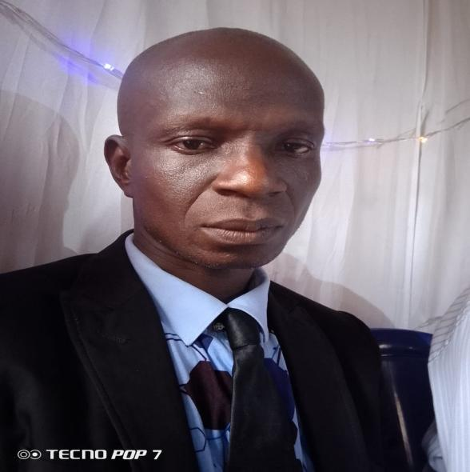



#### ****4. Monitoring and Evaluation****

Quarterly monitoring and evaluation were conducted by the EKHIS team.

5. **Store Records**

The following store records were properly maintained:

* **Assets Register**
* **Store Ledger**
* **Store Requisition Forms**
* **Store Issue and Receipt Vouchers**

All items procured during the year were accurately documented and recorded.

#### ****6. Staff Verification Exercise****

The Internal Audit Unit carried out a staff verification exercise to ensure accurate personnel records across all sections of the Agency. The purpose of this exercise was to verify rumors that some staff had traveled abroad without approval while remaining on the nominal roll and payroll of the State.

The verification exercise, conducted discreetly, confirmed that these rumors were false, and no such irregularities were found within the Agency. This integrity check was completed successfully to uphold transparency and accountability.

*****A.S. ILESANMI******Certified Internal Auditor (CIA)*****





*****Capacity Building*****

|  |  |  |  |  |  |  |  |  |  |  |
| --- | --- | --- | --- | --- | --- | --- | --- | --- | --- | --- |
| 图片12**GA**  ***Monitoring and Evaluation/ Standard Quality Assurance*** | Governance and Administration  **SCORECARD OF EKHIS QA/M&E** | Financial  Management | **Human Resources** | **Patient Care Management** | MCHS | **Drug management system** | **Laboratory** | **infection control** | **HMIS** | **Physical infraructure** |
| **ISE/ORUN** | **98** | **60** | **69** | **87** | **80** | **63** | **68** | **80** | **80** | **80** |
| **IRE/IFE** | **94** | **64** | **73** | **84** | **67** | **58** | **77** | **64** | **91** | **63** |
| **IKOLE** | **99** | **78** | **71** | **100** | **99** | **94** | **79** | **98** | **97** | **82** |
| **OYE** | **89** | **75** | **63** | **86** | **76** | **69** | **85** | **57** | **100** | **77** |
| **MOBA** | **82** | **51** | **68** | **70** | **50** | **64** | **61** | **49** | **64** | **75** |
| **IDO/OSI** | **84** | **52** | **61** | **93** | **85** | **66** | **84** | **80** | **94** | **77** |
| **ILEJEMEJE** | **95** | **24** | **53** | **67** | **63** | **44** | **55** | **70** | **50** | **56** |
| **EKITI EAST** | **88** | **61** | **58** | **53** | **44** | **27** | **40** | **45** | **86** | **50** |
| **IKERE** | **98** | **72** | **81** | **99** | **83** | **87** | **95** | **93** | **91** | **76** |
| **EMURE** | **98** | **70** | **63** | **74** | **58** | **61** | **65** | **62** | **97** | **81** |
| **EKITI SOUTHWEST** | **100** | **42** | **64** | **83** | **44** | **53** | **68** | **91** | **85** | **68** |
| **EFON** | **96** | **71** | **56** | **74** | **62** | **46** | **38** | **58** | **90** | **56** |
| **GBONYIN** | **98** | **61** | **74** | **87** | **92** | **61** | **75** | **88** | **100** | **78** |
| **IJERO** | **93** | **60** | **68** | **78** | **68** | **61** | **73** | **86** | **60** | **63** |
| **EKITI WEST** | **76** | **59** | **58** | **77** | **60** | **71** | **53** | **70** | **57** | **88** |
| **ADO** | **78** | **42** | **64** | **46** | **41** | **20** | **38** | **31** | **87** | **39** |



|  |  |  |  |  |  |  |  |  |  |
| --- | --- | --- | --- | --- | --- | --- | --- | --- | --- |
| **Governanace and**  **Administration** | **Financial**  **management** | **Human**  **Resources** | **Patient Care**  **Management** | MCHS | **Drug management system** | **Laboratory** | **infection**  **control** | **HMIS** | **Physical**  **infrastructure** |
| **91** | **59** | **65** | **79** | **67** | **59** | **66** | **70** | **83** | **69** |





***Ekiti State Health Insurance Scheme***

***On Radio***



***Ekiti State Health Insurance Scheme On Radio***

EKHIS expanded its reach, enrolling thousands of new beneficiaries across communities. A key highlight of the year was the introduction of a 13-week live radio program aired on three major stations—MIDAS FM, CRUISE FM, and EKITI FM. This initiative aimed to sensitize the public about the benefits of health insurance, promote awareness, and drive enrollment, especially in underserved areas.

With enhanced partnerships with healthcare providers, innovative payment models, and a focus on maternal and child health, chronic disease management, and preventive care, EKHIS continues to empower Ekiti residents to lead healthier lives. The scheme remains committed to delivering accessible healthcare for all, a cornerstone of Ekiti State's development agenda.

***Data Analysis***

**Ulerawa Program Monthly Utilization Overview (Jan-Dec 2024)**

|  |  |  |  |  |  |  |  |
| --- | --- | --- | --- | --- | --- | --- | --- |
| **MONTH** | **ANC** | **MALARIA** | **IMMUNIZATION** | **DELIVERY** | **FAMILY**  **PLANNING** | **OTHER CU 5 SERVICES** | **TOTAL** |
| **JAN** | 4024 | 11445 | 9912 | 392 | 2319 | 3041 | **31133** |
| **FEB** | 3971 | 11840 | 13220 | 413 | 2383 | 3804 | **35631** |
| **MAR** | 3430 | 10153 | 11446 | 489 | 1819 | 3129 | **30466** |
| **APRIL** | 3827 | 13417 | 11578 | 457 | 2337 | 3219 | **34835** |
| **MAY** | 3699 | 14638 | 10866 | 488 | 2421 | 2646 | **34758** |
| **JUNE** | 2630 | 11478 | 9446 | 321 | 1868 | 2227 | **27970** |
| **JULY** | 3820 | 17461 | 12086 | 416 | 2225 | 3112 | **39120** |
| **AUG** | 3023 | 15098 | 9657 | 377 | 1895 | 2101 | **32151** |
| **SEP** | 3295 | 12920 | 9722 | 401 | 1730 | 2302 | **30370** |
| **OCT** | 3157 | 14113 | 9233 | 462 | 1719 | 3497 | **32181** |
| **NOV** | 3083 | 13327 | 8461 | 437 | 1569 | 2788 | **29665** |
| **DEC** | 2532 | 9375 | 6756 | 312 | 1514 | 1719 | **22208** |
| **TOTAL**  ***Service utilization peaked in July with 39,120 total utilization, primarily driven by Malaria treatment and Immunization services.***  ***December saw the lowest utilization at 22,208, with significant drops in Malaria and Immunization services.***  ***Family Planning and ANC services remained relatively consistent throughout the year.***  ***Malaria treatment showed significant monthly fluctuations, while Immunization services maintained steady demand.*** | **40491** | **155265** | **122383** | **4965** | **23799** | **33585** | **380488** |

***In 2024, Ekiti East led in service utilization (45,940), while Ijero recorded the lowest (9,723), highlighting significant disparities. Moderate usage was seen in Ikere (34,379) and Ikole (32,637), suggesting the need for balanced service delivery across LGAs.***

|  |  |  |
| --- | --- | --- |
| **The 20 most utilized PHCs under the ulerawa program Based on services utilized:Jan -Dec 2024.** | | |
| **S/N** | **Facility** | **Total services Utilized** |
| 1 | Comprehensive Health Centre, Okesha | 15393 |
| 2 | Comprehensive Health Centre,Omuooke 2 | 9657 |
| 3 | BHC Igbara Odo | 9279 |
| 4 | Comprehensive Health Centre Atiba | 9071 |
| 5 | Basic Health Centre, Iludofin | 7849 |
| 6 | Comprehensive Health Centre, Afao, Ikere | 6383 |
| 7 | Basic Health Centre, Iworo | 6194 |
| 8 | Methodist Comprehensive Health Centre Ikole | 5001 |
| 9 | Comprehensive Health Centre Ilisa | 4661 |
| 10 | Basic Health Centre Ogotum | 4915 |
| 11 | Basic Health Centre Ilasa | 4721 |
| 12 | Comprehensive Health Centre, Oye | 4605 |
| 13 | Basic Health Centre Ayegbaju | 3996 |
| 14 | Comprehensive Health Centre Iwaro | 3916 |
| 15 | Comprehensive Health Centre, Otun | 3932 |
| 16 | Basic Health Centre, Ijan I | 3820 |
| 17 | Basic Health Centre Irona | 3347 |
| 18 | Basic Health Centre Odo Ado | 3513 |
| 19 | Comprehensive Health Centre, Igbemo | 2961 |
| 20 | Comprehensive Health Centre, Ifaki | 2019 |





**Healthcare Utilization Analysis Across LGAs in Ekiti State Under the BHCPF in 2024**

|  |  |  |  |  |  |  |  |
| --- | --- | --- | --- | --- | --- | --- | --- |
| **LGA** | **Total visit** | **Refferal** | **ANC visit** | **Normal Delivery** | **URTI** | **Malaria** | **Other Services** |
| ADO | 13987 | 1079 | 3272 | 230 | 1390 | 2123 | 5944 |
| OYE | 11305 | 140 | 488 | 99 | 1402 | 4391 | 4795 |
| EKITI EAST | 10629 | 48 | 725 | 39 | 1553 | 4685 | 3585 |
| GBONYIN | 8787 | 84 | 443 | 32 | 1488 | 3494 | 3252 |
| EKITI S OUTH WEST | 7597 | 126 | 134 | 32 | 1430 | 2791 | 3087 |
| IDO/OSI | 6905 | 133 | 513 | 77 | 1119 | 2267 | 2806 |
| IKERE | 5996 | 151 | 603 | 27 | 1234 | 2055 | 1960 |
| IKOLE | 5364 | 126 | 426 | 60 | 602 | 1819 | 2340 |
| MOBA | 5241 | 48 | 183 | 27 | 667 | 1586 | 2745 |
| IJERO | 4800 | 68 | 201 | 24 | 419 | 1617 | 2486 |
| ILEJEMEJE | 4415 | 11 | 131 | 18 | 644 | 1703 | 1910 |
| EKITI WEST | 4183 | 49 | 128 | 30 | 1074 | 1942 | 966 |
| EFON | 3699 | 12 | 176 | 11 | 613 | 1419 | 1470 |
| ISE ORUN | 3555 | 18 | 134 | 16 | 839 | 1902 | 645 |
| IRE/IFE | 3475 | 134 | 257 | 20 | 869 | 1609 | 600 |
| EMURE | 2603 | 26 | 89 | 7 | 265 | 1424 | 807 |
| **TOTAL** | **102541** | **2253** | **7903** | **749** | **15608** | **36827** | **39398** |

*Ado led in total visits (13,987), referrals (1079), antenatal care visits (3,272), and normal deliveries (230), highlighting its dominance across key healthcare metrics. Ekiti East recorded the highest malaria cases (4,575), contributing significantly to the total malaria burden of 36,827 cases (37.8% of all reported cases). Upper Respiratory Tract Infections (URTI) were also prevalent, with a total of 15,608 cases, led by Ekiti East (1,553) and followed by Gbonyin (1,488). Emure consistently reported the lowest figures, with only 2,603 total visits, 26 referrals, 89 antenatal care visits, and 7 normal deliveries, indicating gaps in healthcare access or utilization. Other LGAs such as Oye (11,305 visits, 4,391 malaria cases) and Gbonyin (8,787 visits, 3,494 malaria cases) also showed significant activity, emphasizing the need for targeted interventions to address localized healthcare challenges.*



***Achievements in 2024***

***Achievements***

* These efforts were instrumental in changing public perceptions and behaviors regarding healthcare utilization, leading to higher rates of insurance utilization and greater community participation in the program.

**Data-Driven Decision-Making**

* Improved data collection systems and reporting mechanisms enabled more accurate monitoring and evaluation of the health insurance scheme’s progress.
* By leveraging data for decision-making, the program ensured that resources were allocated effectively and that interventions were tailored to meet the evolving needs of the population. This data-driven approach is vital for the continued success and expansion of the program in future years.

**Financial Protection for Vulnerable Populations**

* The Ekiti State Health Insurance Scheme provided critical financial protection for vulnerable populations, reducing the out-of-pocket expenses that families often face when seeking healthcare.

**Expansion of Healthcare Coverage**

* The Ekiti State Health Insurance Scheme significantly increased health insurance coverage, prioritizing maternal and child health services to ensure better healthcare access for these vulnerable groups.

**Capacity Building and Workforce Development**

* Operational training programs were conducted for Officers-in-Charge (OICs) and frontline healthcare workers to improve the effective and efficient delivery of services under the Ekiti State Health Insurance Scheme.
* The healthcare workforce also benefited from specialized training on service delivery protocols and the operational management of the insurance program, further enhancing the quality of healthcare provided at primary healthcare levels throughout the state.

**Increased Community Awareness and Engagement**

* Extensive community sensitization and engagement activities were carried out to raise awareness about the benefits of health insurance and to encourage enrollment in the program.



**Improved Vaccination Coverage**

* The vaccination coverage for children in Ekiti State saw a significant improvement, with the percentage of fully vaccinated children increasing by 38% in 2024. ***(NDHS, 2024)***
* This increase in vaccination rates provided children with vital protection against a range of life-threatening diseases, contributing to the overall improvement of public health in the state.

**Improved Access to Maternal and Child Health Services**

* Maternal and child health services were given top priority, offering essential, cost-effective services such as antenatal care (ANC), safe delivery, postnatal care (PNC), and immunization for children.
* By focusing on improving access to these vital services, the scheme ensured that mothers and children in participating facilities received the necessary care to reduce health risks and prevent avoidable health complications.
* By offering health coverage to low-income households, the scheme shielded vulnerable groups from catastrophic health expenditures, ensuring access to necessary services without the burden of financial strain.

**Service Delivery**

* In 2024, the scheme provided over 500,000 services across various healthcare domains, including antenatal care, malaria treatment, immunization, and family planning services.
* This large-scale service provision contributed significantly to improving the overall health outcomes of the state’s residents, addressing key health challenges such as maternal mortality and childhood diseases.

**Reduction in Early Childhood Mortality**

* Early childhood mortality rates saw impressive reductions, with neonatal mortality dropping by 57%, infant mortality
* decreasing by 53%, and child mortality reducing by 55%. ***(NDHS, 2024)***
* Overall, under-5 mortality decreased by 54%. These reductions reflect the effectiveness of the health insurance scheme in improving healthcare access and outcomes for young children, reducing preventable deaths.



**Improvement in Skilled Birth Attendance**

* The percentage of facility-based deliveries attended by skilled birth workers showed a remarkable increase, rising from 71.8% to 81.7% in some areas and from 87.1% to 93.5% in others. ***(NDHS, 2024)***
* This increase in skilled attendance at births directly contributed to the reduction of maternal mortality rates, ensuring safer delivery experiences for mothers and better health outcomes for newborns.

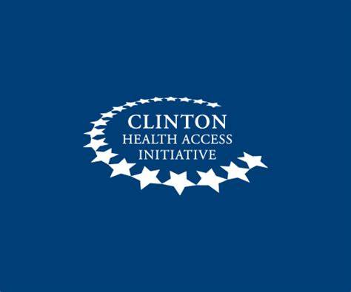

***From the***

***Partner***

The annual report outlines progress achieved in program implementation in Ekiti State from January to December 2024. Key accomplishments during this period include the successful completion of Phase 1 enrollment, focus group discussions (FGDs) to understand clients' motivations and service needs for social health insurance uptake in the informal sector, and support for coordinating platforms through the inauguration of the Health Financing and Human Resources for Health (HRH) Technical Working Groups (TWGs). Additionally, dissemination meetings were conducted to share findings from the RCA workshop, technical training sessions were organized for the EKHIS technical team on health financing and health insurance programming, and quarterly quality assessments were conducted at healthcare facilities. On-the-job mentoring for facility officers-in-charge (OICs) on BHCPF operationalization was rolled out, and support was provided to State Health MDAs for the development of the 2025 Annual Operational Plan (AOP).

Since the signing of the Memorandum of Understanding (MOU) in January 2024, the first phase of beneficiary enrollment was successfully concluded, and the second phase was initiated

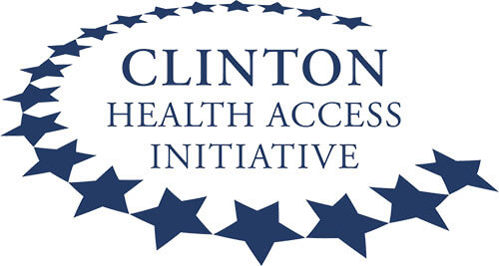



**Overview of 2024 CHAI Ekiti Activities**

In March 2022, CHAI commenced the implementation of the 3.5-year GAC-funded project aimed at expanding health insurance to improve sexual and reproductive health outcomes in six states (Bayelsa, **Ekiti**, Kaduna, Katsina, Niger, and Ondo). The project aims to increase coverage of gender-responsive sexual, reproductive, maternal, newborn, and child health (SRMNCH) services in the target states. The program has been designed with three key objectives:

1. Increase coverage of the state health insurance scheme to the formal and informal sectors to ensure delivery of gender responsive SRMNCH services to vulnerable populations.
2. Increase access to gender responsive SRMNCH services for the most vulnerable populations in target states.
3. Improve the enabling policy environment for gender responsive SRMNCH services for the most vulnerable populations.

The annual report outlines progress achieved in program implementation in Ekiti State from January to December 2024. Key accomplishments during this period include the successful completion of Phase 1 enrollment, focus group discussions (FGDs) to understand clients' motivations and service needs for social health insurance uptake in the informal sector, and support for coordinating platforms through the inauguration of the Health Financing and Human Resources for Health (HRH) Technical Working Groups (TWGs).

Additionally, in Q2 of 2024, CHAI initiated monthly mentoring activities. The mentoring aims to offer targeted support to healthcare workers to address the identified gaps from QA data analysis across the facilities in the state. CHAI leveraged the mentoring visits to identify and address capacity gaps and to enhance the quality-of-service provision by improving quarterly business plans (QBPs) and ensuring the effective implementation of the Basic Healthcare Provision Fund (BHCPF) program. CHAI also conducted periodic mentoring review meetings aimed at fostering peer-to-peer learning among LGA mentors. These meetings serve to assess the progress made against specific indicators and to facilitate constructive dialogue between state actors and LGA mentors.

In alignment with efforts to enhance the policy environment for gender-responsive SRMNCH services for vulnerable populations, CHAI supported Ekiti State in inaugurating Health Financing TWGs in Q1 2024. In November 2024, CHAI worked with key stakeholders, including representatives from the Ministries of Finance, health education institutions, civil society organizations (CSOs), and health regulatory bodies, to present a vacancy analysis report to the State. This process was endorsed by the Honourable Commissioner, leading to the establishment of the HRH TWG.

The program has enrolled 17,025 beneficiaries (41% Pregnant Women; 59% Children under five) in the state as of January 2025 with enrollment still ongoing. These enrollees are eligible to receive fully subsidized insurance coverage for access to SRMNCH services and have commenced accessing services, including ANC services, malaria treatment, pneumonia treatment, diarrhoea treatment, immunization services, family planning, labor & delivery, and post-natal services. In addition to this, CHAI in collaboration with EKHIS conducted demand generation activities across the selected LGAs, in order to increase visibility for the ULERAWA program.

In 2024, CHAI continued the progress recorded towards expanding health insurance to the formal and informal sectors and this is largely linked to the design and conduct of a qualitative assessment to understand motivators and barriers towards health insurance uptake among the informal sector population. Findings from this assessment will be leveraged to support states in designing marketing strategies for their informal sector in 2025.

CHAI, in collaboration with NHIA and academic facilitators, completed technical training on health financing and health insurance programming for EKHIS technical team.



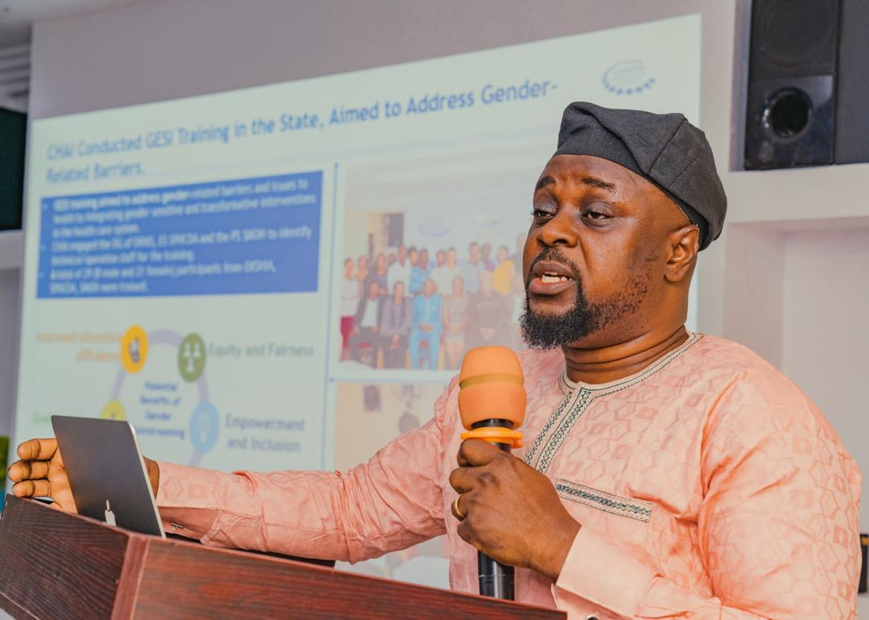



Finally, CHAI provided technical support to program states actors and health MDAs to identify and set state-specific health priorities that will inform the 2025 AOP and aligns with the National Health Sector Strategic Blueprint. Ensuring activities are SMART, evidence-based and informed by bottlenecks identified from facility and LGA analysis.

***CHAI Team***

